*Article Type:*Letter

*Title:* **Egg size variation in a long-lived polyandrous shorebird in the context of senescence and breeding phenology**

*Authors:* Luke J. Eberhart-Hertel*†1, Lourenço Falcão Rodrigues*†2,3, Johannes Krietsch4, Anne G. Eberhart-Hertel5,6, Medardo Cruz-López7, Karina Alejandra Vázquez-Rojas1, Erick González-Medina8, Julia Schroeder3, and Clemens Küpper*1

*Affiliations:*

1Research Group Behavioural Genetics and Evolutionary Ecology, Max Planck Institute for Ornithology, Seewiesen, Germany

2Department of Ecology, Autonomous University of Madrid, Madrid, Spain

3Department of Life Sciences, Imperial College London, Silwood Park Campus, United Kingdom

4Department of Behavioural Ecology and Evolutionary Genetics, Max Planck Institute for Ornithology, Seewiesen, Germany

5Research Group for Movement Ecology, Senckenberg Biodiversity and Climate Research Centre, Frankfurt, Germany

6Behavioural Ecology, Department of Biology, Ludwig-Maximilians University of Munich, Planegg-Martinsried, Germany

7Institute of Ocean Sciences and Limnology, Universidad Nacional Autónoma de México, Ciudad de Mexico, Mexico

8Conservation Biology Research Group, Department of Anatomy, Cell Biology & Zoology, University of Extremadura, Badajoz, Spain

*\**Corresponding authors: luke.eberhart@orn.mpg.de, [lourenco.falc](mailto:lourenco.falcao@uam.es)[ao@uam.es](mailto:ao@uam.es), ckuepper@orn.mpg.de,

†These authors contributed equally.

*Short Running Title:*Egg size variation in a polyandrous shorebird

*Keywords:* ageing, *Charadrius nivosus*, disposable soma, life history, mating system, reproductive investment, reproductive performance, season, snowy plover, trade-off.

*Total Word Count:* 6667

*Abstract (279 words):*

Anisogamy is a central component of sex role evolution, however, the effect of female-female mating competition on egg size variation in polyandrous species is unclear. Moreover, egg size may also be shaped by age-dependent trade-offs between reproductive investments and somatic maintenance that are responsible for senescence. Here we investigate how mating behaviour and senescence are associated with egg size variation in female snowy plovers (*Charadrius nivosus*). Snowy plovers are long-lived shorebirds (longevity record: 20 years) that often produce several nests each year, with females either sequentially changing partners between breeding attempts or remaining monogamous between attempts. We examined how age, seasonality, body size, and mating behaviour relate to within- and between-female variation in egg volume using repeated measures collected over a 15-year period. We found no evidence of reproductive senescence in egg volume in snowy plover females. Rather, egg volume, polyandry, and re-nesting were strongly linked to breeding phenology: early breeding females had a higher likelihood of being polyandrous or replacing failed clutches, yet these individuals laid smaller eggs likely due to physiological limitations associated with the early season. Older individuals and local recruits secured the earliest breeding opportunities in the season suggesting that prior experience could give an edge in the female-female competition for mates. Larger females laid the largest eggs, as expected, but there was no relationship between body size and lay date – implying that size may not provide an advantage in female-female competition. Our findings highlight the existence of several direct and indirect constraints on female reproductive investment that likely shape individual variation in lifetime reproductive success. Future research investigating reproductive senescence of wild populations should consider mating system dynamics when examining variation in reproductive investment.

*Impact Summary (292 words):*

The divergent gamete sizes of males and females (anisogamy) is a key principle for sex role evolution, however, it remains unclear whether and how egg size variation is shaped by female-female competition in species with reversed sex roles. Furthermore, polygamy is typically associated with age such that egg size variation may also be shaped by age-dependent processes including senescence. Here, we use a 15-year longitudinal mark-recapture dataset of a wild subtropical population of snowy plovers (*Charadrius nivosus*) breeding in western Mexico to investigate how mating behaviour and senescence are associated with egg size variation. The snowy plover is a long-lived shorebird characterized by a flexible polyandrous mating system. This rare breeding behaviour represents a unique background for investigating senescence in light of individual variation in reproductive investment. We found no evidence of reproductive senescence in egg volume or polyandry. Instead, egg volume and polyandry were strongly linked to the seasonal timing of breeding: early nesting females had a higher likelihood of being polyandrous but laid smaller eggs. Early nesters also had a higher probability of laying a replacement clutch following breeding failure. Taken together, this suggests that females are driven to initiate laying as early as possible despite the cost this has on egg size of their early season clutches. Furthermore, older individuals and local recruits secured the earliest breeding opportunities in the season indicating that prior experience gave individuals an advantage in the competition for mates. Larger females laid the largest eggs, as expected, but there was no relationship between body size and lay date – implying that size is not an important factor in female-female competition. We conclude that individual female reproductive performance is regulated by flexible mating behaviour (i.e., monogamy or polyandry), age- and season-dependent effects, and prior local experience.

INTRODUCTION (1224 words)

The divergent gamete size of males and females (anisogamy) is fundamental for sex role evolution, however, to what extent female-female competition relates to egg size variation in sex role reversed species remains unclear. At the species level, comparative analysis of birds has shown that a lineage’s egg size tends to decrease following the evolution of polyandry (Liker *et al.*, 2001) – supposedly due to the selective advantages that producing smaller eggs has on minimizing the laying period between matings (Goymann *et al.*, 2015) and, hence, maximizing a female’s reproductive output given temporal constraints to her breeding schedule (Andersson, 2004). But at the individual level, how does egg size variation relate to the reproductive benefits of female mating behaviour?

A female’s breeding schedule depends, in part, on her local resource availability to commence a breeding attempt – resources that include vacant space for reproductive activities (e.g., courting, nesting, etc.), food to launch egg production, and accessible mates (Emlen & Oring, 1977). In sequentially polyandrous species, females compete over these breeding resources to maximize their opportunity for multiple breeding attempts, often resulting in high inter-female variation in reproductive success and breeding schedule (e.g., Colwell & Oring, 1988; Schamel *et al.*, 2004). Females that can reproduce early during the season have more time to replace a failed first attempt (Morrison *et al.*, 2019) and/or to pursue sequential breeding attempts. Moreover, in environments with limited or seasonally dependent resources, breeding early may give offspring favourable conditions to outcompete conspecifics, ultimately reducing the amount of parental care required and maximizing offspring survival prospects (Arnold *et al.*, 2004). However, breeding early may come with the increased physiological stress to egg-laying females, and/or may result in an increased likelihood of brood failure in environments with high stochasticity, such as low food availability, inclement weather, or frequency-dependent predation risk, associated with the early season (Borgmann *et al.*, 2013; Ockendon *et al.*, 2013). Taken together, a seasonal trade-off between quality and quantity exists for females: early nesters may compromise resource investment into their first clutches in the race to maximize time for multiple breeding attempts (Andersson, 2004).

In many organisms, reproductive productivity is age-dependent (Bouwhuis *et al.*, 2009; Hammers *et al.*, 2012; Lemaître *et al.*, 2015; Zhang *et al.*, 2015; Salguero-Gómez *et al.*, 2016; Jankowiak *et al.*, 2018; Dingemanse *et al.*, 2020): an individual’s performance increases over early life to a maximum and is followed by a decline in older ages. The increase in breeding performance in early life is thought to be an indication of physiological or competitive inferiority of inexperienced breeders compared to older conspecifics (Curio, 1983), whereas the decline in reproductive performance at old age is considered senescence – a within-individual age-specific decline in reproductive performance paired with an increase in mortality risk caused by the loss of physiological and cellular function (Medawar, 1952; Williams, 1957). A prominent hypothesis explaining the occurrence of senescence is the disposable soma theory (*sensu* Kirkwood, 1977): individuals are constrained by the amount of resources they have to invest in survival and reproduction (Kirkwood & Austad, 2000). Senescence is therefore the consequence of age-dependent trade-offs between energy investments in reproduction at the expense of somatic repair (Kirkwood & Rose, 1991; Kirkwood & Austad, 2000; Drenos & Kirkwood, 2005). Thus, an individual’s investment in current reproduction may exacerbate physiological and cellular damage, which might have knock-on effects on their capability for future reproductive investments at older ages – ultimately impairing performance.

A key methodological issue for studying senescence in wild populations is that stochastic extrinsic mortality reduces the frequency of individuals in older age classes, hence making it challenging to disentangle between- vs. within-individual age-dependent variation – a phenomenon known as “selective disappearance” (van de Pol & Verhulst, 2006; Nussey *et al.*, 2008). Investigations using longitudinal data to test for senescence are particularly suitable for this task, as they can control for the confounding effects of selective disappearance through repeated measures of individuals as they age (van de Pol & Verhulst, 2006; Nussey *et al.*, 2008; Dingemanse *et al.*, 2020).

In oviparous organisms, egg size represents a fundamental measure of female reproductive investment (Kaplan, 1980; Fox, 1994; Williams, 1994; Starck & Ricklefs, 1998; Moran & Emlet, 2001; Xu *et al.*, 2019) and is shown to be related to inter- and intra-specific variation in several life history traits: for example, egg size is associated with developmental mode, with precocial species typically producing larger eggs than altricial species (Deeming & Reynolds, 2015). Within individuals, variation in egg size is shown to be highly repeatable (Christians, 2002), and age-dependent changes in egg or clutch size are often consistent with senescence although complicated by considerable between-individual variation (Beamonte-Barrientos *et al.*, 2010; Dingemanse *et al.*, 2020).

Among oviparous animals, shorebirds (part of the order Charadriiformes) produce some of the largest eggs in relation to body mass due to the needs of their precocial nidifugous young (Lack, 1968; Rahn *et al.*, 1975). As a clade, shorebirds also exhibit a disproportionately high prevalence of polyandry (Oring, 1986; Andersson, 2005; Colwell, 2010). Sexual and natural selection presumably act divergently on egg size: natural selection on offspring viability favours larger eggs with more nutrients to enhance offspring survival (Blomqvist *et al.*, 1997; Starck & Ricklefs, 1998; Williams, 2012), whereas sexual selection on polyandry favours rapid clutch completion to maximize time for multiple nesting attempts – a process that may indirectly reduce egg size (Liker *et al.*, 2001; Andersson, 2004).

Here, we investigate seasonal- and age-dependent egg size variation using a 15-year longitudinal mark-recapture dataset of snowy plovers (*Charadrius nivosus*). The snowy plover is a long-lived shorebird (longevity record: 20 years; Colwell *et al.*, 2017) exhibiting a rare breeding behaviour characterized by sex-role reversal including facultative sequential polyandry whereby females regularly desert their broods after hatching to start a new breeding attempt with another male (Warriner *et al.*, 1986; Eberhart-Phillips *et al.*, 2017; Kupán *et al.*, 2021). Their breeding season can extend up to six months allowing for multiple nesting attempts following successful fledging of young or replacing failed nests due to depredation or flooding (Eberhart-Phillips, 2019). Desertion and re-mating rates decline with season in polyandrous plovers (Amat *et al.*, 1999; Székely *et al.*, 1999; Cruz-López *et al.*, 2017; Kupán *et al.*, 2021) suggesting strong competition between females over males with established nesting territories early in the season. First, we examine whether variation in mating strategy, egg size, and breeding schedule are age-related and follow a pattern typical for senescence. Following others (i.e., Bouwhuis *et al.*, 2009; Jankowiak *et al.*, 2018), we hypothesized that a pattern of early-life increase in egg size and advance in lay date, followed by a peak maximum, and a decline thereafter, would be indicative of senescence. Conversely, older females may have a higher likelihood of polyandry owing to experience or competitive advantages over younger conspecifics (Oring *et al.*, 1994). Second, we assess the seasonal relationship between egg size and a female’s potential for multiple clutches in the context of reproductive trade-offs associated with female-female competition over mates. Here, we hypothesized that the likelihood of polyandry would be inversely associated with lay date whereas egg size and lay date should be positively associated: early breeding females would have the highest rates of seasonal polyandry but would also lay the smallest eggs. Likewise, we predicted that early breeding females that lost their first clutch would have the highest rates of re-nesting but lay smaller eggs than late breeding females.

MATERIALS AND METHODS (2457 words)

*Data collection*

We studied the reproductive effort and breeding schedules of snowy plovers at Bahía de Ceuta – an important breeding site located on the coast of Sinaloa, western Mexico (23o54’N, 106o57’W). Details on the study site and population are provided elsewhere (e.g., Cruz-López *et al.*, 2017; Eberhart-Phillips *et al.*, 2020a). In brief, we annually monitored breeding birds from mid-April until early July, and collected mark-recapture data following the methods described in (Székely *et al.*, 2011). We searched for nests using telescopes and mobile hides to minimize disturbance. Upon finding a nest, we measured each eggs’ length and width to the nearest tenth of a mm to determine egg size (Figs. S1a, b). Using these egg dimensions, we calculated egg volume (Fig. S1c) following (Hoyt, 1979) as:

Eq. 1 $egg volume= K × length × {width}^{2}$,

where *K* is 0.486, a volume-index constant for snowy plovers determined by (Székely *et al.*, 1994) through the use of an egg volumeter (Hanson, 1954). The modal clutch size of snowy plovers is three (86.2%) and is the maximum number of eggs we have observed in this population (Eberhart-Phillips *et al.*, 2020b). We regularly checked incomplete nests until the clutch was completed and assigned the age of these nests according to the lay date of the last egg laid (Plaschke *et al.*, 2019). If the clutch was complete upon discovery and had not been incubated longer than 10 days, we determined its lay date by floating the egg and estimating the stage of embryonic development (Nosály & Székely, 1993). For successful clutches that had been incubated for more than 10 days we back-calculated the laying date based on the hatching date assuming an incubation period of 25 days (Plaschke *et al.*, 2019). In the rare case that the nest did not hatch and we discovered it after day 10 of incubation, we assumed that the nest was 17 days old upon discovery (i.e., the midpoint between the minimum age of 11 days and the 25 day incubation period). In summary, the lay dates for 778 (92.5%) nests were determined through flotation, 45 (5.4%) were back-calculated from hatch date, and 18 (2.1%) were assumed to be 17 days old at discovery.

We identified previously marked nesting adults based on their unique colour ring combination. We captured unmarked adults on their nests during incubation using funnel traps (Hall & Cavitt, 2012) and assigned a unique colour ring combination for subsequent recognition. Because snowy plovers have circadian sex roles during incubation (Vincze *et al.*, 2017), we generally targeted females for captures during the day and males during the night. In the rare circumstance when we were unable to identify parents before hatching, we attempted to capture parents while they tended chicks. As snowy plovers only show a small degree of sexual dimorphism (Küpper *et al.*, 2009), we determined the sex of all captured plovers in the field through a combination of plumage characteristics (Argüelles-Tico *et al.*, 2015), time of capture, and other behavioural cues (e.g., sex-specific brood care; (Kupán *et al.*, 2021). For a subset of adults (57.5%), we confirmed sex molecularly from DNA extracted from blood samples through PCR amplification of Z and W specific DNA regions with two sex-typing markers: P2/P8 and Calex-31 (Griffiths *et al.*, 1998; Küpper *et al.*, 2007; Remedios *et al.*, 2010).

We visited known active nests every four or five days to determine the status of the nest (e.g., active, depredated, etc.) until the 20th day after egg laying and thereafter daily until the eggs hatched or failed. We weighed chicks shortly after hatching (879 [84.7%] within 24 hours of hatching, 159 [15.3%] during the second day after hatching) and marked them with an alphanumeric metal and a single colour ring for subsequent identification in the chance that these individuals recruited into the breeding population as adults in future years.

For the years 2006 to 2016 all longitudinal data collected has been compiled as part of the *CeutaOPEN* project – an open-access database for individual-based field studies in evolutionary ecology and conservation biology (Eberhart-Phillips *et al.*, 2020a). We accessed these data directly from the open source repository (Eberhart-Phillips *et al.*, 2020b) and supplemented them with data from four additional field seasons: 2017–2020. The *CeutaOPEN* database is composed of five tables that correspond to our routine data collection in the field (Székely & Kosztolányi, 2006). Here we used the “Captures”, “Resights”, and “Nests” tables. The “Captures” and “Resights” tables contain information about all the individuals captured and observed, whereas the “Nests” table contains the morphometric and spatiotemporal information related to each nest monitored. Please refer to our RMarkdown vignette that connects to *CeutaOPEN* and reproduces all analytical methods and results presented below (Supplementary File 1).

*Statistical Analyses*

*Age estimation of individuals with unknown origin*—Investigating age-dependent processes in the wild is challenging as the analyses often involve a mix of individuals that are of known or unknown age (Colchero *et al.*, 2012) – with the former being initially marked at birth (i.e., uncensored), and the latter being immigrants of unknown age or those that were born before the study’s first marking occasion (i.e., left-truncated). To estimate the ages of unknown individuals in our marked population we employed a capture-mark-recapture analysis using the ‘Bayesian Survival Trajectory Analysis’ (BaSTA) package in R (v1.9.4, Colchero *et al.*, 2012), which uses a Bayesian hierarchical framework to fit parametric survival functions of the marked population while accounting for imperfect detection. Furthermore, BaSTA derives birth year estimates of left-truncated individuals from the population mean of the projected survival function. As snowy plovers show prominent sex differences in survival (Eberhart-Phillips *et al.*, 2017; 2018), we used female-specific survival functions for this study. Due to high natal dispersal, we could not confidently determine the fate of juveniles marked in our population. To acknowledge this uncertainty, our capture-mark-recapture sample only included individuals that survived to their first breeding season, i.e., we constrained first-year survival probability to 1.

In total, our capture-mark-recapture data comprised records of 450 uniquely marked females, of which 45 hatched locally and subsequently recruited into the adult population as known-age individuals (Fig. 1a), and the remaining 405 females were adults of unknown age and origin. We monitored the presence or absence of marked individuals by recapturing or observing them in the field in all study years except for 2014, amounting to a total of 916 post-birth annual detections of the 450 females in our sample (median annual detections per adult = 2; mean = 2.04, 1.45 SD). A logistic bathtub-shaped mortality model had the best fit to our data – revealing that female mortality rate increased until age 5 years, after which it became constant (Fig. 1b; see Appendix S1 for detailed methods). Using this model, we extracted the birth year estimate posteriors for each unknown-age individual in the capture-mark-recapture sample. Note that three individuals (one first encountered as an adult [CA1579] and two local recruits [CA2036 and CA1526]; Fig. 2) had been already marked two years prior to the start of our monitoring period (i.e., pre-2006) and were thus added to our sample after running BaSTA on the 2006–2020 capture-mark-recapture data.

*Modelling individual variation in egg volume (“Egg volume model”)*—Our sample for studying egg volume dynamics included 2392 eggs from 841 nests belonging to 426 females. 56 (13.1%) females had three or more years of repeated measures (Fig. 2), 83 (19.5%) had two years of repeated measures, and 286 (67.4%) were measured in a single year. Furthermore, 43 (10.1%) individuals in our sample were marked as hatchlings but later recruited as breeding adults in subsequent years (i.e., known age; Fig. 2a), with the remaining 38 (89.9%) individuals being initially marked as adults (i.e., unknown age; Fig. 2b). We followed common statistical approaches to investigate senescence in birds (e.g., (Bouwhuis *et al.*, 2009; 2010; Schroeder *et al.*, 2012; Herborn *et al.*, 2016; Graham *et al.*, 2019; Dingemanse *et al.*, 2020) by fitting a quadratic function of age to model age-specific trends in egg volume. We controlled for selective appearance and disappearance of females differing in average egg volume by fitting ‘first observed age’ and ‘last observed age’ as fixed effects – a method that estimates between-individual age effects introduced by selective disappearance and appearance (van de Pol & Verhulst, 2006; Dingemanse *et al.*, 2020).

We modelled within-individual age effects on egg volume by fitting a univariate mixed-effect model, that included linear and quadratic forms of a within-group deviation score for age (henceforth ‘age-deviance’), calculated for individual *i* at age *j* as: *ageij* – [*first observed age*]*i* (van de Pol & Verhulst, 2006; Snijders & Bosker, 2011). Tarsus length was also included as a fixed effect to control for female structural size, and was averaged over an individual’s measurements (i.e., our *a priori* expectation was that tarsus length is static throughout adult life and that any variation in this trait was due to measurement error) – grand average 24.73 mm (0.73 SD), grand average within-individual standard deviation 0.22 mm (1.13 SD). In addition to these fixed covariates, we included a quadratic function of lay date to assess seasonal variation in egg volume as several shorebird studies report seasonal increases (Skrade & Dinsmore, 2013; Kwon *et al.*, 2018) or decreases in egg volume (Dittmann & Hötker, 2001; Skrade & Dinsmore, 2013; Kwon et al., 2018; Kubelka et al., 2020; Verhoeven et al., 2020). To disentangle within- from between-individual effects in lay date, we used the same logic as with age above: first lay dates of all individuals each year represented the between-individual seasonal effect, whereas the deviation in lay dates of an individual relative to its first nest of the season represented the within-individual seasonal effect. We included random intercepts for nest, individual, and year, and assumed a Gaussian error distribution of egg volume.

*Modelling seasonal variation in polyandry potential (“Polyandry model”)*—Our sample for studying seasonal polyandry dynamics included 426 females for which the identity of their mates had been verified through observation. We defined observed polyandry as a binomial variable that scored an individual as being monogamous or polyandrous each year based on our observations of them having one or multiple breeding partners, respectively (see Fig. 2 for an example of the sampling distribution). By definition, all polyandrous cases bred at least twice within a season, but also 12.4% of monogamous females were observed breeding more than once. Overall, we observed 92 cases of polyandry from 76 females over the 15-year period (annual average incidence of observed polyandry: 11.8%, range: 0–25.6%). Monogamous females remained with the same partner for another breeding attempt only after their initial attempt had failed. To assess the relationship between the likelihood of polyandry and lay date and age, we fitted a binomial linear mixed effects model that tested the likelihood of polyandry predicted by the fixed effects of lay date (i.e., of an individual’s first nest of the season), age-deviance (see above), and first observed age. We included individual and year as random effects.

*Modelling seasonal variation in re-nesting potential (“Re-nesting model”)*—Our sample for studying seasonal re-nesting dynamics included 177 females for which the fate of their first nest of the season had been verified as a failure. We defined re-nesting as a binomial variable that scored an individual as being a re-nester or a single-nester each year based on our observations of them attempting to re-nest after the loss of their first clutch or not, respectively. Overall, we observed 64 cases of re-nesting from 55 females over the 15-year period following a failed attempt (annual average incidence of observed re-nesting: 27%, range: 0–58.3%). Most cases of re-nesting are monogamous in this population (92.4%; see Fig. 2 for an example of the sampling distribution). To assess the relationship between the likelihood of re-nesting and lay date, we fitted a binomial linear mixed effects model that tested the likelihood of re-nesting predicted by the fixed effect of lay date (i.e., of an individual’s first nest of the season). We included individual and year as random effects.

*Modelling individual variation in lay dat*e *(“Lay date model”)*— Modelling the age effects of first nest lay date followed the same logic as the above egg volume model, with a univariate mixed-effect structure that included age-deviance, age-deviance-squared, first observed age, last observed age, and average tarsus length as fixed covariates, and individual and year as random intercepts. Furthermore, recruitment status was also fitted as a two-level fixed effect describing if a breeding female hatched locally (“local recruit”) or was first encountered as an adult of unknown origin (“immigrant”). Our sample for studying lay date dynamics used the same nest-level sample as the polyandry model above, however, as we were interested in how the recruitment status of an individual influenced breeding phenology, we excluded data from 2006 as this was the first year of our study when all birds were first individually marked. This resulted in 568 nests from 376 females. We visualized the distribution of lay dates to confirm normality and to assess the population-level variance in breeding schedule – an indication of inter-female breeding asynchrony and the intensity of competition for mates (Andersson, 2004).

*Evaluating effect sizes and uncertainty*—We used the “lme4” (Bates et al., 2015), “rptR” (Stoffel *et al.*, 2017) and “partR2” (Stoffel *et al.*, 2020) packages in R version “Bunny-Wunnies Freak Out” (R Core Team, 2020) to conduct our statistical modelling and assessed homoscedasticity by visually examining the residuals (see Fig. S4). For each of the four mixed-effect models described above, we evaluated uncertainty in our parameter estimates by simulating 1000 parametric bootstraps via the “partR2::partR2” function (Stoffel *et al.*, 2020). Likewise we derived nest-, individual-, and year-level repeatabilities (i.e., intra-class correlations) by simulating 1000 parametric bootstraps of the four mixed-effect models using “rptR::rpt”. We report fixed effects as standardized regression coefficients (i.e., beta weights) and repeatability as the ‘adjusted repeatability’ – interpreted as the repeatability of a given hierarchical group after controlling for fixed effects (Nakagawa & Schielzeth, 2010).

To ensure that intercepts of our age-dependent models represented the reproductive performance for the earliest age at reproduction (i.e., age 1 in snowy plovers, Page et al., 2009), we fitted age as ‘*age* – 1’ – otherwise it would represent reproduction as age 0, which is an empirically meaningless estimate. For the “Egg volume model” and “Lay date model” we ran an additional simulation that acknowledged uncertainty in the BaSTA age estimate of a given individual: we bootstrapped each model 1000 times, with every iteration randomly drawing a birth year estimate for unknown aged individuals from their posterior distributions provided by BaSTA. For both simulations, we evaluated the influence of birth year uncertainty by examining the effect size distribution of the 1000 bootstraps in relation to the 95% confidence interval for effect sizes of the original model that used the median birth year estimate from BaSTA.

RESULTS(941 words)

The modal clutch size of the 841 clutches was 3 eggs (724 nests, 86.1%; 2-eggs: 103 nests, 12.3%, 1-egg: 14 nests, 1.6%). Average egg length was 3.09 cm (0.10 cm SD, Fig. S1a) and width was 2.24 cm (0.05 cm SD, Fig. S1b), which translated into an average egg volume of 7.59 cm3 (0.46 cm3 SD). The average egg volume of a clutch strongly predicted the average hatch weight of the subsequent brood (*β* [95% CIs]: 0.63 [0.55–0.70]; R2*marginal* = 0.370 [0.310–0.436]; Figs. S1c and S3, Table S2, see Appendix S2 for methods). Based on BaSTA’s estimated birth year, 185 of the 383 unknown-age females in our sample were first observed nesting at age 1 (48.3%), 120 at age two (31.3%), 72 at age three (18.8%), five at age 4 (1.3%), and one at age 5 (0.3%). Of the 43 locally hatched females in our sample, 29 first nested at age one (67.4%), six were first observed nesting at age two (14.0%), two at age 3 (4.7%), three at age 4 (7.0%), three at ages 5, 7, and 8, respectively (7.0%). The average local tenure of all females in the sample was 1.57 years (2.15 SD) with an average age span of 3.12 years (2.03 SD, median: 3, range: 1–14 years) and an average of 1.56 years of observed ages per female (1.04 SD, median: 1, range: 1–8 age-specific observations). Females in our sample were typically observed nesting every consecutive year since their first observation, however, some individuals skipped years (Fig. 2, average yearly interval between nesting attempts = 1.07, 0.27 SD). On average, females made 1.43 (0.56 SD) nesting attempts per season (median = 1, range 1 to 3).

*Individual variation in egg volume*

Overall, mixed effects accounted for 71.2% ([68.2, 74.3] 95%CIs) of variation in egg volume, with fixed effects explaining 7.9% ([5.1, 12.3] 95%CIs) of this variation (Table S3). Females were highly repeatable in their egg volumes between clutches: *r* = 0.47 ([0.41, 0.53] 95%CIs; Fig. 3, Table S3). Furthermore, eggs within the same clutch were moderately repeatable in volume (*r* = 0.18 [0.14, 0.22]; Fig. 3, Table S3). Senescence in egg volume was not supported (*βage* [95% CIs]: 0.00 [-0.06, 0.6], *βage2*: -0.05 [-0.09, -0.01]; semi-partial *R*2 of senescence function = 0.003 [0, 0.05]; Fig. 3, Table S3). Furthermore, we found no support for selective (dis)appearance of individuals according to egg volume, as the 95% CIs for first and last observed ages of reproduction overlapped zero (Fig. 3, Table S3). The bootstrap analysis incorporating the individual birth-year posteriors estimated from BaSTA (Fig. S8a–c) confirmed these results. The strongest fixed effect explaining egg volume variation was the structural size of the mother (*βtarsus* [95% CI]: 0.23 [0.15, 0.29]; semi-partial *R*2 of female tarsus = 0.05 [0.02, 0.09]; Figs. S3 and S6b): larger females laid larger eggs than smaller females (model predicted difference: 0.58 *cm*3 [0.34, 0.81] 95%CI). The second strongest effect was the between-individual quadratic season function (Fig. 4c): eggs were smallest at the start of the season (model prediction: 7.18 *cm*3 [6.98, 7.37] 95%CI) and largest shortly after the middle of the season (model prediction: 7.68 *cm*3 [7.60, 7.76] 95%CI). Average egg volume also increased between sequential clutches within individuals but with smaller magnitude than the population-level trend (*βwithin* [ 95%CI]: 0.10 [0.06, 0.14], predicted increase of 0.21 *cm*3 [0.04, 0.38]; Fig. 3).

*Seasonal variation in polyandry and re-nesting potential*

A female’s probability of being polyandrous was strongly dependent on the lay date of their first nest with early breeders being more likely to be polyandrous than late breeders (*β* [95% CIs]: -2.25 [-3.12, -1.84]; *R*2*marginal* = 0.37 [0.27, 0.50]; Figs. 4a and S4, Table S4). Likewise, a female’s likelihood of re-nesting following a failed attempt decreased with advancing lay date of the first nest (*β* [95% CIs]: -1.77 [-3.15, -1.30]; *R*2*marginal* = 0.39 [0.25, 0.58]; Figs. 4e and S5, Table S5). The lay date distribution of polyandrous females was bimodal, with peaks in the first and second nests occurring 11.1 days before and 29.1 days after the unimodal seasonal peak for monogamous females (Fig. 4b). Likewise, the lay date distribution of renesting females was also bimodal, with peaks in the first and replacement clutches occurring 9.7 days before and 28.4 days after the unimodal seasonal peak for single nesters (Fig. 4d). Females had low repeatability in polyandry among years (adjusted individual cross-year repeatability (*r* [95% CIs] = 0.01 [0, 0.15]; Table S4, Fig. S4) and we found no evidence of age-dependent polyandry (Fig. S4).

*Individual variation in lay date*

Females had moderate repeatability in the lay date of their first nest among years (*r* = 0.19 [0.06, 0.32] 95%CI; Fig. 3, Table S6). We found strong support for the effect of origin on first nest lay date: females that locally hatched and later recruited into the breeding population initiated nests 7.80 days earlier (95% CI: [5.09, 10.50]) on average compared to conspecifics whose origin was unknown (Figs. 3 and 5b). The next strongest fixed effect was the within-individual age function predicting the lay date of a female’s first nest in the season: young individuals laid later nests compared to their older conspecifics with lay date advancing by ~2.17 days per year until age six (95% CI: [1.41, 2.93]; Fig. 5a), after which the uncertainty in the trend became unwieldly in the oldest age classes of our sample (Fig. 5a). Notably, female size did not affect lay date (Fig. 3 and S7a), nor did between-individual effects of first or last age at breeding (Fig. 3). The bootstrap analysis incorporating the individual birth-year posteriors estimated from BaSTA (Fig. S8d–f) confirmed these results.

DISCUSSION(2045 words)

Identifying trade-offs between reproductive effort and survival in wild organisms is central for understanding of the evolutionary mechanisms of senescence (Lemaître *et al.*, 2015). Consistent with previous work (Christians, 2002), we found that egg size was highly repeatable for individual females, even after controlling for their structural size. However, our data show that egg size variation in snowy plovers is not a senescent trait – but is rather a seasonally dynamic trait likely linked to female-female competition to breed early. The distribution of lay dates in this snowy plover population extended over a 112-day period, indicating high phenological asynchrony within the breeding population, a pre-cursor for intra-sexual competition (Andersson, 2004). Early nesting females had a much higher likelihood of being sequentially polyandrous or re-nesting than late breeders, likely because early nesting allows enough time for multiple chances to re-mate or lay replacement clutches (Morrison *et al.*, 2019). Early season nesters had on average smaller eggs than females starting to breed at a later date suggesting a trade-off between mating strategy and gamete investment (Andersson et al. 2004). This was supported by the observed within-individual effect: females generally increased egg volume between consecutive nesting attempts, albeit the effect size was small. A seasonal increase in egg volume at both between- and within-individual levels may indicate that maternal investment during early breeding attempts is impaired by a combination of several mutually non-exclusive physiological constraints including, but not limited to, low food availability (Steigerwald *et al.*, 2015), pressure to initiate and complete egg-laying quickly (Birkhead & Nettleship, 1982), and carry-over costs associated with intense competition (Duckworth, 2006) or migratory status (Crossin *et al.*, 2010). In contrast, late breeders can take advantage of a slower pace to gather more resources and maximize investment during egg production – while having only enough time for a single breeding attempt.

Despite being long-lived and investing substantially in reproduction year-after-year, we found no evidence of age-dependent trade-offs in egg size or polyandry potential in this snowy plover population. Older females tended to initiate nests earlier in the season compared to their younger conspecifics – indicating age-dependent competitive ability that could reflect local experience. However, this age-dependent variation in lay date followed a non-linear pattern: lay date advanced with each year of age until a peak at age six, after which the age-lay date trajectory was unclear because of limited sampling in older age classes. Moreover, locally recruited females (i.e., hatched locally) bred earlier than immigrant females, further suggesting a competitive advantage for individuals with prior experience at the breeding site (which would also apply to older females that bred at the study site before). Importantly, polyandry was not repeatable within individuals – likely due to stochastic socio-ecological dynamics, such as local mate availability and breeding success, which have been suggested to influence mating tactics in plovers (Carmona-Isunza *et al.*, 2017; Eberhart-Phillips *et al.*, 2017; Halimubieke *et al.*, 2020).

Several studies of oviparous organisms have observed age-dependent variation in egg size, with some studies finding a positive relationship (Cooch *et al.*, 1992; Flint & Sedinger, 1992; Robertson *et al.*, 1994; Warner *et al.*, 2016; Verhoeven *et al.*, 2020) and others observing a negative relationship (Reid, 1988; Potti, 1993; Ito, 1997). However, earlier studies often failed to account for selective disappearance (e.g., Cooch *et al.*, 1992; Flint & Sedinger, 1992; Potti, 1993) and thus complicate the interpretation of individual- vs. population-level effects. Recent longitudinal studies document an increase in egg size in early life, followed by peak and then a late-life decline (Bouwhuis *et al.*, 2009; Jankowiak *et al.*, 2018). The early-life increase in egg size may indicate individual improvement through more efficient foraging abilities, better mate choice, or improved predator avoidance (Forslund & Pärt, 1995). Although we did not find clear statistical support for a relationship between age and egg volume, we did find strong evidence of females nesting earlier as they aged. We suspect that this early-life delay in lay date is related to the inferior competitive abilities or lack of experience that young females have when faced with the seasonal competition for early breeding opportunities (Oring *et al.*, 1994) – especially when they are migrants and arrive later then local winter residents (Grist *et al.*, 2017).

In snowy plovers, a completed clutch equals approximately 60% of a female’s body mass (Page *et al.*, 2009) – a substantial investment that young females may not be physiologically ready for at the start of their first breeding season. Such a constraint would force yearlings to commence egg laying after the earliest attempts by more mature females – especially when they hatched late or experienced poor conditions during the juvenile stage. We have recorded females first breeding as early as 10 months after hatching (Eberhart-Phillips *et al.*, 2020b) – an age at which females may be unable to invest heavily into reproduction. However, we have observed some of these locally recruited females already being polyandrous in their first year meaning that they can be competitive in the female-female competition over mates. Given that we have documented females still breeding at an age of 13 years (Fig. 2), it is remarkable that we find no evidence of senescence. Such within-individual consistency over life becomes relevant when considering the developmental mode of snowy plovers. For plovers with their nidifugous chicks, small egg volume differences may have significant ramifications for chick survival (Starck & Ricklefs, 1998), as chicks are not fed by the parents but rather must forage for themselves immediately after hatching. In shorebirds, larger chicks that hatch from larger eggs typically survive better than smaller chicks (Blomqvist et al. 1997), likely owing to the extra nutrients provided by a large egg that make up for the body mass reduction during the first few days of life when foraging efficiency is reduced due to learning (Ricklefs, 1968). Moreover, chicks of polyandrous females are typically cared for solely by their father, forcing them to rely more on their intrinsic reserves than the added benefits of biparental care. Consequently, comparatively small differences in egg size could have large knock-on effects for chick survival (Williams, 1994; Starck & Ricklefs, 1998) – meaning that a females’ potential to save resources by reducing egg volume is limited.

Most studies conducted on temperate or high latitude breeding shorebirds have found a negative association between time of the season and egg size (Byrkjedal & Kalas, 1985; Sandercock *et al.*, 1999; Kubelka *et al.*, 2020) although in polyandrous red-necked phalaropes (*Phalaropus lobatus*)egg size increased across the breeding season (Kwon *et al.*, 2018, n.b., the presented effect size is small). However, many investigations of seasonal egg size dynamics did not disentangle whether the observed changes were due to within- or between-individual effects. For example, laying schedules associated with female quality and/or age could be responsible for much of the observed seasonal variation in egg size. A study including 15 arctic shorebirds suggested that indeed between-individual variation may account for more of the seasonal variation in egg size than within-individual variation (Weiser *et al.*, 2018). We observed a between-individual quadratic effect of time of season on egg size: early and late season clutches had on average smaller eggs than those nesting at the middle of the season. The within-individual effect complemented the population-level trend, with eggs of sequential nests being larger than those of first clutches.

Past studies have linked polyandry and sex-role reversal to reduced female gamete size (Slotow, 1996; Andersson, 2004), as smaller eggs would permit females to produce several clutches in rapid succession (Liker *et al.*, 2001). Although it is intuitive to interpret our results as support for polyandrous females limiting their reproductive investment into the first clutch by producing small eggs to enable them to quickly produce a second clutch, this is an unlikely explanation for the observed seasonal variation in egg size. Rather, we argue that the observed seasonal variation in egg size is a result of mating strategy and environmental conditions that both favour early breeders. Clutches produced early and late during the season generally contained smaller eggs (Fig. 4). Although early breeding by females may be constrained by obtaining adequate energy reserves for egg production, it provides a head-start in the competition for mates and allows these females to exploit sequential mating opportunities later in the season or lay replacement clutches following stochastic failure of their first attempts (Morrison *et al.*, 2019). Nest failures may put early females on a monogamous trajectory as re-nesting after nest loss almost always happens with the same mate (Halimubieke *et al.*, 2019). However, if the clutch is successful, early breeding females almost always desert broods within a few days of hatching (Kupán et al. 2021) and will become polyandrous. The reduced egg size at the end of the season can be explained by late nesting females being under a tight schedule to complete nesting before impending high tides and precipitation flood the breeding grounds (Plaschke *et al.*, 2019), however, it should be noted that the late season effect size for egg volume is small and within our margin of measurement error.

Egg size may also be tied to the survival prospects of the young. Notably in this population, chick survival is especially high for nests laid at the beginning of the season despite the smaller egg volumes of early clutches – suggesting a higher resource availability and lower predation rate for chicks hatching from early clutches (Cruz-López *et al.*, 2017; Kupán *et al.*, 2021). As the season progresses, chick survival declines (Cruz-López *et al.*, 2017) and many chicks originating from late nesting attempts die from starvation as the local water bodies that sustain invertebrate prey communities dry out. At the time of laying, late nesting females undergo oogenesis during the local peak in resource availability, likely producing the larger eggs found in the latter half of the season – a maternal effect that may help to counter reduced chick survival when conditions deteriorate 25 days later after hatch. All things considered, we think that the seasonal constraints of resource availability for breeding plovers are a better explanation for the differences in reproductive investment by females than the mating strategy *per se*.

One limitation of our study is that some snowy plover females show high breeding dispersal and can produce sequential nests hundreds of kilometres apart (Stenzel *et al.*, 1994; D'Urban Jackson *et al.*, 2020). As our population is open to immigration and emigration, we have likely missed documenting polyandrous breeding attempts at unmonitored neighbouring nesting sites – meaning that we underestimate the true extent of polyandry. Yet, our observed laying distribution (Fig. 4b) suggests that this limitation is not a major concern because we would have otherwise expected a larger share of seemingly monogamous females breeding at the beginning and end of the breeding season – instead we see that monogamous breeders tend to nest in the middle of the season. This is also true for re-nesting activity following failed attempts: birds that did not lay replacement clutches tended to nest in the middle of the season (Fig. 4d). Furthermore, we acknowledge that our relatively small sample of known-age individuals presents a limitation to our study reflecting the challenge of studying an open wild population with high natal dispersal.

In conclusion, we show that egg size variation in snowy plovers is highly repeatable within females and remains stable over life despite a substantial cumulative maternal investment. Egg size variation may be driven by local seasonal fluctuations in resource availability and a reproductive advantage for early nesting females. Our results suggest that senescence is not a major driver of age-dependent dynamics of egg size – a surprising result that is inconsistent with the disposable soma theory. Yet, our results show that prior experience gives older and local females a competitive advantage over younger and naïve conspecifics scrambling for early breeding opportunities that are at the heart of the polyandrous mating strategy (Andersson 2004). We suggest that future research should explore whether and how polygamy and senescence interact to affect reproductive output and what consequences these factors have on offspring survival. Furthermore, future reproductive senescence studies should be wary about cryptic collinearity between age and seasonal trait variation because age-dependent patterns may be misinterpreted when seasonal dynamics are unaccounted for. Studying patterns of senescence in wild populations with flexible mating systems may help shed light on how variation in mating strategies shapes individual life history trajectories and lifetime reproductive success.

ACKNOWLEDGEMENTS

We dedicate this article to our colleague and friend René Beamonte-Barrientos who tragically passed away in March 2016. René worked on senescence in birds including snowy plovers and inspired us to conduct this study. We thank Salvador Ángel del Gómez, Miguel Guevara-Medina and Ivan Guardado for assistance with fieldwork, and Daniel Galindo-Espinosa for logistic support. We also thank Martin Bulla, Niels Dingemanse, Wolfgang Forstmeier, Bart Kempenaers, and Martin Stoffel for constructive discussions and statistical advice. Fieldwork was conducted under permit from SEMARNAT (SGPA/DVGS/2631/19). A full list of funding for fieldwork is provided on [www.chorlito.org](http://www.chorlito.org). LJE-H was funded by the German Science Foundation (DFG Eigene Stelle grant: 415037502). AGE-H was funded by the European Union’s Horizon 2020 research and innovation programme under the Marie Skłodowska-Curie grant agreement No 793077 and the German Science Foundation (DFG Eigene Stelle grant: 448621093). MCL was supported by a doctoral grant from CONACyT (248125/378124) and the Cornell Lab of Ornithology ‘Coastal Solutions Fellowship’. CK was supported by the Max Planck Society.

AUTHOR CONTRIBUTIONS

LJE-H, CK, and JS: conceived and supervised the study

LJE-H, LF, CK, MC-L, KAV-R, and EG-M: collected the data

LJE-H, LF, and AGE-H: conducted the analysis and wrote the accompanying RMarkdown document (Supplementary File 1)

LJE-H, LF, JK, AGE-H, and CK: interpreted the results

LJE-H, LF, and CK: wrote the manuscript

All authors helped to revise the manuscript and approved the final version.

DATA ACCESSIBILITY

We provide all computer code and documentation as a html vignette written in Rmarkdown (File S1) together with all the raw datasets needed to reproduce our modeling and analyses – these files can be found in this project’s Open Science Framework repository: [doi.org/ 10.17605/OSF.IO/UCW6J](https://osf.io/ucw6j/)

LITERATURE CITED

Amat, J.A., Fraga, R.M. & Arroyo, G.M. (1999) Brood desertion and polygamous breeding in the Kentish plover *Charadrius alexandrinus*. *Ibis*, **141**, 596–607.

Andersson, M. (2004) Social polyandry, parental investment, sexual selection, and evolution of reduced female gamete size. *Evolution*, **58**, 24–34.

Andersson, M. (2005) Evolution of classical polyandry: three steps to female emancipation. *Ethology*, **111**, 1–23.

Argüelles-Tico, A., Küpper, C., Kelsh, R.N., Kosztolányi, A., Székely, T. & van Dijk, R.E. (2015) Geographic variation in breeding system and environment predicts melanin-based plumage ornamentation of male and female Kentish plovers. *Behavioral Ecology and Sociobiology*, **70**, 49–60.

Arnold, J.M., Hatch, J.J. & Nisbet, I.C. (2004) Seasonal declines in reproductive success of the common tern *Sterna hirundo*: timing or parental quality? *Journal of Avian Biology*, **35**, 33–45.

Beamonte-Barrientos, R., Velando, A., Drummond, H. & Torres, R. (2010) Senescence of maternal effects: aging influences egg quality and rearing capacities of a long‐lived bird. *The American Naturalist*, **175**, 469–480.

Birkhead, T.R. & Nettleship, D.N. (1982) The adaptive significance of egg size and laying date in thick-billed Murres *Uria lomvia*. *Ecology*, **63**, 300–306.

Blomqvist, D., Johansson, O.C. & Götmark, F. (1997) Parental quality and egg size affect chick survival in a precocial bird, the lapwing *Vanellus vanellus*. *Oecologia*, **110**, 18–24.

Borgmann, K.L., Conway, C.J. & Morrison, M.L. (2013) Breeding phenology of birds: mechanisms underlying seasonal declines in the risk of nest predation. *PLoS ONE*, **8**, e65909.

Bouwhuis, S., Charmantier, A., Verhulst, S. & Sheldon, B.C. (2010) Trans-generational effects on ageing in a wild bird population. *Journal of Evolutionary Biology*, **23**, 636–642.

Bouwhuis, S., Sheldon, B.C., Verhulst, S. & Charmantier, A. (2009) Great tits growing old: selective disappearance and the partitioning of senescence to stages within the breeding cycle. *Proceedings of the Royal Society B: Biological Sciences*, **276**, 2769–2777.

Byrkjedal, I. & Kalas, J.A. (1985) Seasonal variation in egg size in golden plover *Pluvialis apricaria* and dotterel *Charadrius morinellus* populations. *Ornis Scandinavica*, **16**, 108–112.

Carmona-Isunza, M.C., Ancona, S., Székely, T., Ramallo-González, A.P., Cruz-López, M., Serrano-Meneses, M.A., *et al.* (2017) Adult sex ratio and operational sex ratio exhibit different temporal dynamics in the wild. *Behavioral Ecology*, **28**, 523–532.

Christians, J.K. (2002) Avian egg size: variation within species and inflexibility within individuals. *Biological Reviews of the Cambridge Philosophical Society*, **77**, 1–26.

Colchero, F., Jones, O.R. & Rebke, M. (2012) BaSTA: An R package for Bayesian estimation of age-specific survival from incomplete mark-recapture/recovery data with covariates. *Methods in Ecology and Evolution*, **3**, 466–470.

Colwell, D.M.A. (2010) *Shorebird Ecology, Conservation, and Management*. University of California Press.

Colwell, M.A. & Oring, L.W. (1988) Breeding biology of Wilson's Phalarope in southcentral Saskatchewan. *The Wilson Bulletin*, 567–582.

Colwell, M.A., Feucht, E.J., McAllister, S.E. & Transou, A.N. (2017) Lessons learned from the oldest Snowy Plover. *Wader Study*, **124**, 157–159.

Cooch, E.G., Lank, D.B., Rockwell, R.F. & Cooke, F. (1992) Is There a Positive Relationship between Body Size and Fecundity in Lesser Snow Geese? *The Auk*, **109**, 667–673.

Cox, D.R. & Oakes, D. (1984) *Analysis of Survival Data*. Chapman and Hall, London.

Crossin, G.T., Trathan, P.N., Phillips, R.A., Dawson, A., Le Bouard, F. & Williams, T.D. (2010) A carryover effect of migration underlies individual variation in reproductive readiness and extreme egg size dimorphism in macaroni penguins. *The American Naturalist*, **176**, 357–366.

Cruz-López, M., Eberhart-Phillips, L.J., Fernández, G., Beamonte-Barrientos, R., Székely, T., Serrano-Meneses, M.A., *et al.* (2017) The plight of a plover: viability of an important snowy plover population with flexible brood care in Mexico. *Biological Conservation*, **209**, 440–448.

Curio, E. (1983) Why de young birds reproduce less well? *Ibis*, **125**, 400–404.

D'Urban Jackson, J., Bruford, M.W., Székely, T., DaCosta, J.M., Sorenson, M.D., Russo, I.-R.M., *et al.* (2020) Population differentiation and historical demography of the threatened snowy plover *Charadrius nivosus* (Cassin, 1858). *Conservation Genetics*, **21**, 387–404.

Deeming, D.C. & Reynolds, S.J. (2015) Nests, eggs, and incubation new ideas about avian reproduction. *Avian Biology Research*, **8**, 193.

Dingemanse, N.J., Moiron, M., Araya-Ajoy, Y.G., Mouchet, A. & Abbey-Lee, R.N. (2020) Individual variation in age-dependent reproduction: Fast explorers live fast but senesce young? *Journal of Animal Ecology*, **89**, 601–613.

Drenos, F. & Kirkwood, T.B.L. (2005) Modelling the disposable soma theory of ageing. *Mechanisms of Ageing and Development*, **126**, 99–103.

Duckworth, R.A. (2006) Behavioral correlations across breeding contexts provide a mechanism for a cost of aggression. *Behavioral Ecology*, **17**, 1011–1019.

Eberhart-Phillips, L.J. (2019) Plover breeding systems: diversity and evolutionary origins. In *The population ecology and conservation of Charadrius plovers* (ed. by Colwell, M.A. & Haig, S.M.). pp. 63–88.

Eberhart-Phillips, L.J., Cruz-López, M., Lozano-Angulo, L., Gómez del Ángel, S., Rojas-Abreu, W., Bucio-Pacheco, M., *et al.* (2020a) CeutaOPEN, individual-based field observations of breeding snowy plovers *Charadrius nivosus*. *Scientific Data*, **7**, 149.

Eberhart-Phillips, L.J., Cruz-López, M., Lozano-Angulo, L., Gómez del Ángel, S., Rojas-Abreu, W., Bucio-Pacheco, M., *et al.* (2020b) CeutaOPEN v1.5. Open Science Framework.

Eberhart-Phillips, L.J., Küpper, C., Carmona-Isunza, M.C., Vincze, O., Zefania, S., Cruz-López, M., *et al.* (2018) Demographic causes of adult sex ratio variation and their consequences for parental cooperation. *Nature Communications*, **9**, 1–8.

Eberhart-Phillips, L.J., Küpper, C., Miller, T.E.X., Cruz-López, M., Maher, K.H., Remedios, dos, N., *et al.* (2017) Sex-specific early survival drives adult sex ratio bias in snowy plovers and impacts mating system and population growth. *Proceedings of the National Academy of Sciences of the United States of America*, **114**, e5474–e5481.

Emlen, S.T. & Oring, L.W. (1977) Ecology, sexual selection, and the evolution of mating systems. *Science*, **197**, 215–223.

Flint, P.L. & Sedinger, J.S. (1992) Reproductive implications of egg-size variation in the black brant. *The Auk*, **109**, 896–903.

Forslund, P. & Pärt, T. (1995) Age and reproduction in birds - hypotheses and tests. *Trends in Ecology & Evolution*, **10**, 374–378.

Fox, C.W. (1994) the influence of egg size on offspring performance in the seed beetle, *Callosobruchus maculatus*. *Oikos*, **71**, 321–325.

Gompertz, B. (1812) On the nature of the function expressive of the law of human mortality, and on a new mode of determining the value of life contingencies. *Philosophical Transactions of the Royal Society of London B: Biological Sciences*, **115**, 513–583.

Goymann, W., Makomba, M., Urasa, F. & Schwabl, I. (2015) Social monogamy vs. polyandry: ecological factors associated with sex roles in two closely related birds within the same habitat. *Journal of Evolutionary Biology*, **28**, 1335–1353.

Graham, J.L., Bauer, C.M., Heidinger, B.J., Ketterson, E.D. & Greives, T.J. (2019) Early-breeding females experience greater telomere loss. *Molecular Ecology*, **28**, 114–126.

Griffiths, R., Double, M.C., Orr, K. & Dawson, R.J.G. (1998) A DNA test to sex most birds. *Molecular Ecology*, **7**, 1071–1075.

Grist, H., Daunt, F., Wanless, S., Burthe, S.J., Newell, M.A., Harris, M.P., *et al.* (2017) Reproductive performance of resident and migrant males, females and pairs in a partially migratory bird. *Journal of Animal Ecology*, **86**, 1010–1021.

Halimubieke, N., Kupán, K., Valdebenito, J.O., Kubelka, V., Carmona-Isunza, M.C., Burgas, D., *et al.* (2020) Successful breeding predicts divorce in plovers. *Scientific Reports*, **10**, 15576–13.

Halimubieke, N., Valdebenito, J.O., Harding, P., López, M.C., Meneses, M.A.S., James, R., *et al.* (2019) Mate fidelity in a polygamous shorebird, the snowy plover (*Charadrius nivosus*). *Ecology and Evolution*, **28**, 523.

Hall, L.K. & Cavitt, J.F. (2012) Comparative study of trapping methods for ground-nesting shorebirds. *Waterbirds*, **35**, 342–346.

Hammers, M., Richardson, D.S., Burke, T. & Komdeur, J. (2012) Age-dependent terminal declines in reproductive output in a wild bird. *PLoS ONE*, **7**, e40413.

Hanson, H.C. (1954) Apparatus for the study of incubated bird eggs. *The Journal of Wildlife Management*, **18**, 191–198.

Herborn, K.A., Daunt, F., Heidinger, B.J., Granroth-Wilding, V.H.M., Burthe, S.J., Newell, M.A., *et al.* (2016) Age, oxidative stress exposure and fitness in a long-lived seabird. *Functional Ecology*, **30**, 913–921.

Hoyt, D.F. (1979) Practical methods of estimating volume and fresh weight of bird eggs. *The Auk*, **96**, 73–77.

Ito, K. (1997) Egg-size and -number variations related to maternal size and age, and the relationship between egg size and larval characteristics in an annual marine gastropod, *Haloa japonica* (Opisthobranchia; Cephalaspidea). *Marine Ecology Progress Series*, **152**, 187–195.

Jankowiak, Ł., Zyskowski, D. & Wysocki, D. (2018) Age-specific reproduction and disposable soma in an urban population of Common Blackbirds *Turdus merula*. *Ibis*, **160**, 130–144.

Kaplan, R.H. (1980) The Implications of Ovum Size Variability for Offspring Fitness and Clutch Size within Several Populations of Salamanders (Ambystoma). *Evolution*, **34**, 51–64.

Kirkwood, T.B.L. (1977) Evolution of ageing. *Nature*, **270**, 301–304.

Kirkwood, T.B.L. & Austad, S.N. (2000) Why do we age? *Nature*, **408**, 233–238.

Kirkwood, T.B.L. & Rose, M.R. (1991) Evolution of senescence: late survival sacrificed for reproduction. *Philosophical Transactions of the Royal Society B-Biological Sciences*, **332**, 15–24.

Kubelka, V., Sládeček, M., Zámečník, V., Vozabulová, E. & Šálek, M. (2020) Seasonality predicts egg size better than nesting habitat in a precocial shorebird. *Ardea*, **107**, 239.

Kupán, K., Székely, T., Cruz-López, M., Seymour, K. & Küpper, C. (2021) Offspring desertion with care? Chick mortality and plastic female desertion in Snowy Plovers. *Behavioral Ecology*.

Küpper, C., Augustin, J., Kosztolányi, A., Burke, T., Flguerola, J. & Székely, T. (2009) Kentish versus snowy plover: phenotypic and genetic analyses of *Charadrius alexandrinus* reveal divergence of Eurasian and American subspecies. *The Auk*, **126**, 839–852.

Küpper, C., Horsburgh, G.J., Dawson, D.A., ffrench-Constant, R., Székely, T. & Burke, T. (2007) Characterization of 36 polymorphic microsatellite loci in the Kentish plover (*Charadrius alexandrinus*) including two sex-linked loci and their amplification in four other Charadrius species. *Molecular Ecology Notes*, **7**, 35–39.

Kwon, E., English, W.B., Weiser, E.L., Franks, S.E., Hodkinson, D.J., Lank, D.B., *et al.* (2018) Delayed egg-laying and shortened incubation duration of Arctic-breeding shorebirds coincide with climate cooling. *Ecology and Evolution*, **8**, 1339–1351.

Lack, D.L. (1968) *Ecological adaptations for breeding in birds*.

Lemaître, J.-F., Berger, V., Bonenfant, C., Douhard, M., Gamelon, M., Plard, F., *et al.* (2015) Early-late life trade-offs and the evolution of ageing in the wild. *Proceedings of the Royal Society B: Biological Sciences*, **282**, 20150209.

Liker, A., Reynolds, J.D. & Székely, T. (2001) The evolution of egg size in socially polyandrous shorebirds. *Oikos*, **95**, 3–14.

Medawar, P.B.P. (1952) *An Unsolved Problem of Biology*. University College London, London.

Moran, A.L. & Emlet, R.B. (2001) Offspring size and performance in variable environments: field studies on a marine snail. *Ecology*, **82**, 1597–1612.

Morrison, C.A., Alves, J.A., Gunnarsson, T.G., Þórisson, B. & Gill, J.A. (2019) Why do earlier-arriving migratory birds have better breeding success? *Ecology and Evolution*, **9**, 8856–8864.

Nakagawa, S. & Schielzeth, H. (2010) Repeatability for Gaussian and non‐Gaussian data: a practical guide for biologists. *Biological Reviews*, **85**, 935–956.

Nosály, G. & Székely, T. (1993) Clutch and egg-size variation in the Kentish Plover (*Charadrius alexandrinus*) during the breeding season. *Aquila*, **100**, 161–179.

Nussey, D.H., Coulson, T., Festa-Bianchet, M. & Gaillard, J.M. (2008) Measuring senescence in wild animal populations: Towards a longitudinal approach. *Functional Ecology*, **22**, 393–406.

Ockendon, N., Leech, D. & Pearce-Higgins, J.W. (2013) Climatic effects on breeding grounds are more important drivers of breeding phenology in migrant birds than carry-over effects from wintering grounds. *Biology Letters*, **9**, 20130669.

Oring, L.W. (1986) Avian Polyandry. In *Current Ornithology, vol 3*, Current Ornithology, vol 3 (ed. by Johnston, R.F.). pp. 309–351.

Oring, L.W., Reed, M.J. & Alberico, A.J. (1994) Mate acquisition tactics in polyandrous spotted sandpipers (*Actitis macularia*): the role of age and experience. *Behavioral Ecology*, **5**, 9–16.

Page, G.W., Stenzel, L.E., Warriner, J.S., Warriner, J.C. & Paton, P.W. (2009) Snowy Plover (*Charadrius nivosus*). *The Birds of North America Online*, 71935–72002.

Pinder, J.E., Wiener, J.G. & Smith, M.H. (1978) The Weibull distribution: a new method of summarizing survivorship data. *Ecology*, **59**, 175–179.

Plaschke, S., Bulla, M., Cruz-López, M., Gómez del Ángel, S. & Küpper, C. (2019) Nest initiation and flooding in response to season and semi-lunar spring tides in a ground-nesting shorebird. *Frontiers in Zoology*, **16**, 15–11.

Pletcher, S. (1999) Model fitting and hypothesis testing for age-specific mortality data. *Journal of Evolutionary Biology*, **12**, 430–439.

Potti, J. (1993) Environmental, ontogenetic, and genetic variation in egg size of Pied Flycatchers. *Canadian Journal of Zoology-revue Canadienne De Zoologie - CAN J ZOOL*, **71**, 1534–1542.

R Core Team. (2020) *R: A Language and Environment for Statistical Computing*. R Foundation for Statistical Computing, Vienna, Austria. https://www.R-project.org/.

Rahn, H., Paganelli, V.C. & Ar, A. (1975) Relation of avian egg weight to body weight. *The Auk*, **92**, 750–765.

Reid, V.W. (1988) Age-specific patterns of reproduction in the glaucous-winged gull: increased effort with age. *Ecology*, **69**, 1454–1465.

Remedios, dos, N., Lee, P.L., Székely, T., Dawson, D.A. & Küpper, C. (2010) Molecular sex-typing in shorebirds: a review of an essential method for research in evolution, ecology and conservation. *Wader Study Group Bulletin*, **117**, 109–118.

Ricklefs, R.E. (1968) Patterns of growth in birds. *Ibis*, **110**, 419–451.

Robertson, G.J., Cooch, E.G., Lank, D.B., Rockwell, R.F. & Cooke, F. (1994) Female age and egg size in the lesser snow goose. *Journal of Avian Biology*, **25**, 149.

Salguero-Gómez, R., Jones, O.R., Jongejans, E., Blomberg, S.P., Hodgson, D.J., Mbeau-Ache, C., *et al.* (2016) Fast-slow continuum and reproductive strategies structure plant life-history variation worldwide. *Proceedings of the National Academy of Sciences of the United States of America*, **113**, 230–235.

Sandercock, B.K., Lank, D.B. & Cooke, F. (1999) Seasonal declines in the fecundity of arctic-breeding sandpipers: different tactics in two species with an invariant clutch size. *Journal of Avian Biology*, **30**, 460.

Schamel, D., Tracy, D.M. & Lank, D.B. (2004) Male mate choice, male availability and egg production as limitations on polyandry in the red-necked phalarope. *Animal Behaviour*, **67**, 847–853.

Schroeder, J., Burke, T., Mannarelli, M.E., Dawson, D.A. & Nakagawa, S. (2012) Maternal effects and heritability of annual productivity. *Journal of Evolutionary Biology*, **25**, 149–156.

Siler, W. (1979) A Competing‐Risk Model for Animal Mortality. *Ecology*, **60**, 750–757.

Skrade, P. & Dinsmore, S.J. (2013) Egg-size investment in a bird with uniparental incubation by both sexes. *The Condor*, **115**, 508–514.

Slotow, R. (1996) Black coucal *Centropus grillii* egg volume predicts their polyandrous mating system. *Journal of Avian Biology*, 171–173.

Snijders, T. & Bosker, R.J. (2011) *Multilevel analysis: An introduction to basic and advanced multilevel modeling*. 2nd edn. Sage.

Spiegelhalter, D.J., Best, N.G., Carlin, B.P. & Van Der Linde, A. (2002) Bayesian measures of model complexity and fit. *Journal of the Royal Statistical Society: Series B (Statistical Methodology)*, **64**, 583–639.

Starck, J.M. & Ricklefs, R.E. (1998) *Avian growth and development. Evolution within the altricial-precocial spectrum*. New York.

Steigerwald, E.C., Igual, J.-M., Payo-Payo, A. & Tavecchia, G. (2015) Effects of decreased anthropogenic food availability on an opportunistic gull: evidence for a size-mediated response in breeding females. *Ibis*, **157**, 439–448.

Stenzel, L.E., Warriner, J.C., Warriner, J.S., Wilson, K.S., Bidstrup, F.C. & Page, G.W. (1994) Long-distance breeding dispersal of snowy plovers in western North America. *Journal of Animal Ecology*, **63**, 887–902.

Stoffel, M.A., Nakagawa, S. & Schielzeth, H. (2017) rptR: repeatability estimation and variance decomposition by generalized linear mixed‐effects models. *Methods in Ecology and Evolution*, **8**, 1639–1644.

Stoffel, M.A., Nakagawa, S. & Schielzeth, H. (2020) partR2: Partitioning R2 in generalized linear mixed models. *bioRxiv*, 2020.07.26.221168.

Székely, T. & Kosztolányi, A. (2006) Practical guide for investigating breeding ecology of Kentish plover *Charadrius alexandrinus*. *University of Bath*.

Székely, T., Argüelles-Tico, A., Kosztolányi, A. & Küpper, C. (2011) Practical guide for investigating breeding ecology of Kentish plover, 1–16.

Székely, T., Cuthill, I.C. & Kis, J. (1999) Brood desertion in Kentish plover sex differences in remating opportunities. *Behavioral Ecology*, **10**, 185–190.

Székely, T., Kozma, J. & Piti, A. (1994) The volume of snowy plover eggs (el volumen de los huevos de *Charadrius alexandrinus*). *Journal of Field Ornithology*, **65**, 60–64.

van de Pol, M. & Verhulst, S. (2006) Age‐dependent traits: a new statistical model to separate within‐ and between‐individual effects. *The American Naturalist*, **167**, 766–773.

Verhoeven, M.A., Loonstra, A.H.J., McBride, A.D., Tinbergen, J.M., Kentie, R., Hooijmeijer, J.C.E.W., *et al.* (2020) Variation in egg size of black-tailed godwits. *Ardea*, **107**, 291.

Vincze, O., Kosztolányi, A., Barta, Z., Küpper, C., Alrashidi, M., Amat, J.A., *et al.* (2017) Parental cooperation in a changing climate: fluctuating environments predict shifts in care division. *Global Ecology and Biogeography*, **26**, 347–358.

Warner, D.A., Miller, D.A.W., Bronikowski, A.M. & Janzen, F.J. (2016) Decades of field data reveal that turtles senesce in the wild. *Proceedings of the National Academy of Sciences of the United States of America*, **113**, 6502–6507.

Warriner, J.S., Warriner, J.C., Page, G.W. & Stenzel, L.E. (1986) Mating system and reproductive success of a small population of polygamous snowy plovers. *The Wilson Bulletin*, **98**, 15–37.

Weiser, E.L., Brown, S.C., Lanctot, R.B., Gates, H.R., Abraham, K.F., Bentzen, R.L., *et al.* (2018) Life-history tradeoffs revealed by seasonal declines in reproductive traits of Arctic-breeding shorebirds. *Journal of Avian Biology*, **49**, jav–01531.

Williams, G.C. (1957) Pleiotropy, natural selection, and the evolution of senescence. *Evolution*, **11**, 398.

Williams, T.D. (1994) Intraespecific variation in egg size and egg composition in birds: effects on offspring fitness. *Biological Reviews of the Cambridge Philosophical Society*, **69**, 35–59.

Williams, T.D. (2012) *Physiological adaptations for breeding in birds*. Princenton.

Xu, F., Yang, W. & Li, Y. (2019) Enlarged egg size increases offspring fitness of a frog species on the zhoushan archipelago of China. *Scientific Reports*, **9**, 11653.

Zhang, H., Vedder, O., Becker, P.H. & Bouwhuis, S. (2015) Age-dependent trait variation: the relative contribution of within-individual change, selective appearance and disappearance in a long-lived seabird. *Journal of Animal Ecology*, **84**, 797–807.

**FIGURES**

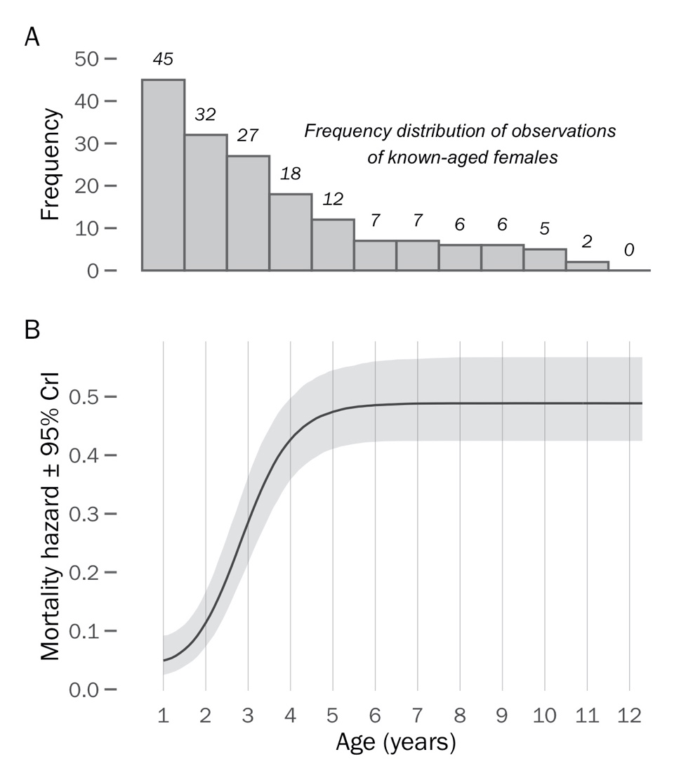

**Figure 1.** Logistic-bathtub mortality function for snowy plover females: a) frequency distribution of age-specific observations of 45 known-aged females and b) age-dependent mortality hazard.

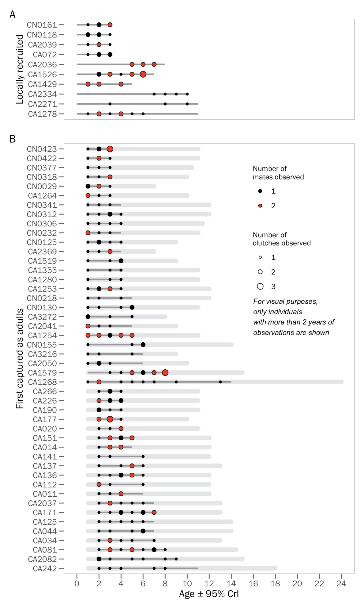**Figure 2.** Mating strategy and clutch number of female snowy plovers according to age. Each row shows an individual female in the population for which we have at least three years of observations (note that our analysis also includes females with one or two years of observation, but given space constraints only individuals with a minimum of three years are plotted in this graph). Panel A) shows known-aged females which were born locally, whereas B) shows females that were initially captured as adults and are therefore of unknown age. Points illustrate the age at which we collected observations of egg volume, with the size of the point corresponding to the number of clutches measured at a given age, and the colour indicating if we observed the female mating with one or two distinct males (i.e., in case of multiple clutches at a given age). The light grey buffer around unknown-age females indicates the 95% CrI of the ages for an individuals’ observed period (i.e., lower limit indicates the minimum age the individual could have entered the population and the upper limit indicates the maximum age of an individual’s last observation based on BaSTA’s birth year posterior). The dark grey lines indicate the period for which an individual was observed alive (i.e., in some cases we encountered an individual in the field and confirmed its survival, but we did not observe its nest to be able to measure the eggs. Note also that the age at first encounter of all known-aged individuals is 0).

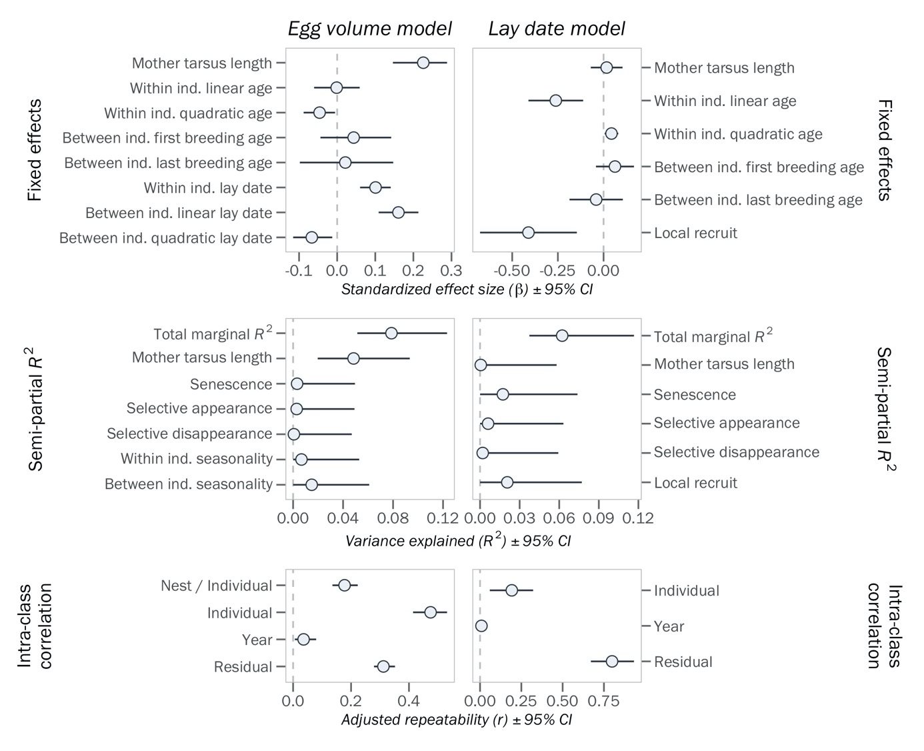**Figure 3.** Sources of egg volume (left) and lay date (right) variation. Top row: standardized effect sizes (± 95% CI) of fixed effects. Middle row: variance explained by fixed effects (note: the term ‘Senescence’ describes the collective variation explained by the linear and quadratic within-individual age effects in the top row; the term ‘Selective appearance’ and ‘Selective disappearance’ describe the variation explained by the between individual first- and last-breeding age fixed effects of the top row, respectively; the term ‘Within ind. seasonality’ describes the variation explained by the within individual lay date effect in the top row, and the term ‘Between ind. seasonality’ describes the collective variation explained by the linear and quadratic lay date effects in the top row).

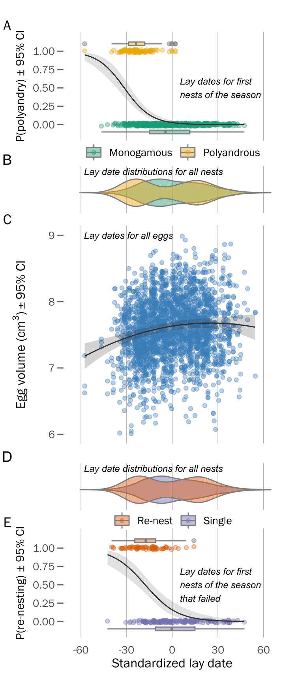**Figure 4.** Phenology of mating behaviours, re-nesting, egg laying, and egg size in 426 female snowy plovers breeding at Bahía de Ceuta. A) Relationship between polyandry potential and lay date of a female’s first nest of the season. Each datum is the lay date of an individual’s first nest and their observed local mating behaviour of each year. B) Lay date distributions of all nests for females that were polyandrous (yellow; 92 nests from 76 females) or monogamous (green; 573 nests from 403 females). C) Seasonal variation in egg volume – trend shows the between-individual polynomial function of the model prediction. Each datum is an egg’s volume (cm3) and lay date. D) Lay date distributions of all nests for females that laid replacement clutches (orange; 64 nests from 127 females) or did not re-nest (purple; 146 nests from 134 females) following failure of their first nest. E) Relationship between re-nesting potential and lay date of a female’s first nest of the season. As with panel (A), each datum is the lay date of an individual’s first nest and their observed local re-nesting activity of each year. Late date is standardized for each year across all panels.

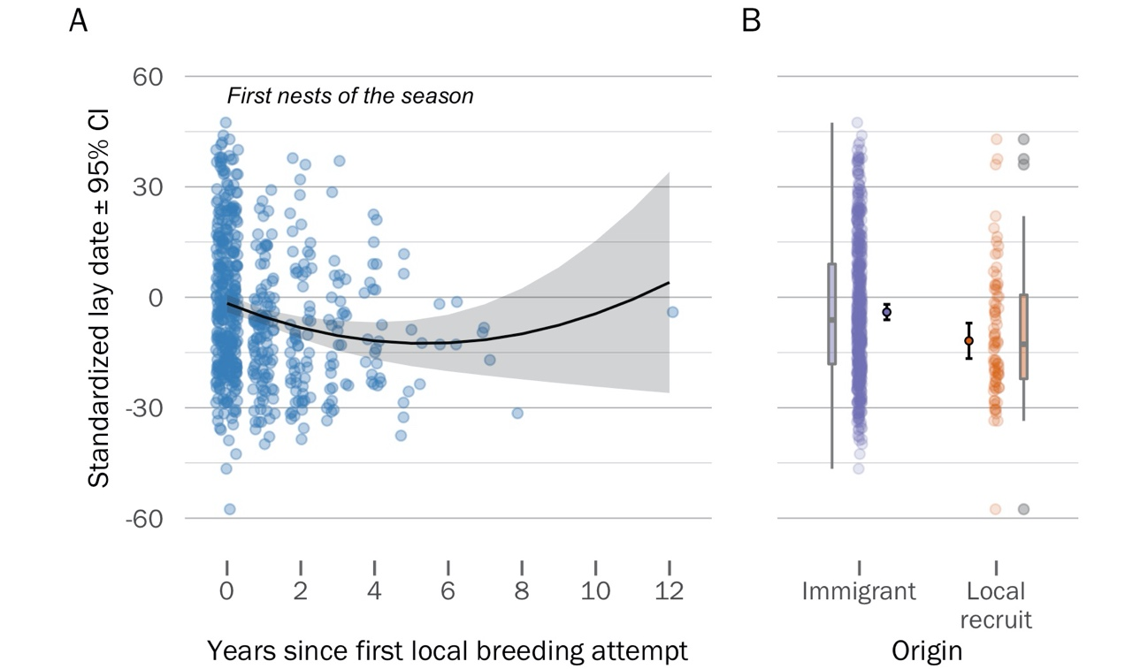

**Figure 5.** Age- and origin-dependent breeding phenology of female snowy plovers. A) Within-individual variation in age-specific nest initiation date – as females gained more experience in the local population, they started nesting earlier, however this trend reversed at older ages (albeit with high uncertainty). Each datum represents an individual’s ‘age-deviance’ (i.e., a within-group centred measure of the number of years since the individual’s first observed local breeding attempt, see *Methods* for more details) and the lay date of its first nest each year. B) Origin-specific variation in nest initiation date – females that hatched locally and recruited into the breeding population (orange) tended to nest earlier than birds originating from elsewhere (purple). Inner-most distributions show the model estimates and 95% CI, outer-most box plots show the inter-quartile ranges of the raw data (point-cloud).

**SUPPLEMENTARY MATERIAL**

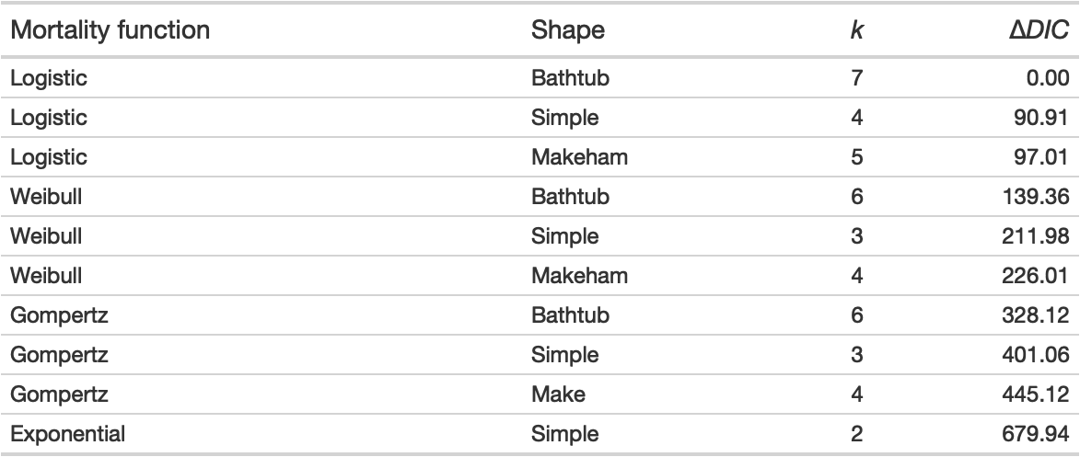**Table S1.** Hierarchical capture-mark-recapture models used to describe mortality patterns of snowy plovers at Bahía de Ceuta, Mexico, between 2006 and 2020. *k:* number of modelled parameters; Δ*DIC:* difference in deviance information criterion (*DIC*) between a given model and the top model. *DIC* value of top model was 5279.1.

**Table S2.** Relationship between the average egg volume of a clutch and the average chick weight at hatching. See Appendix S2 for methods.

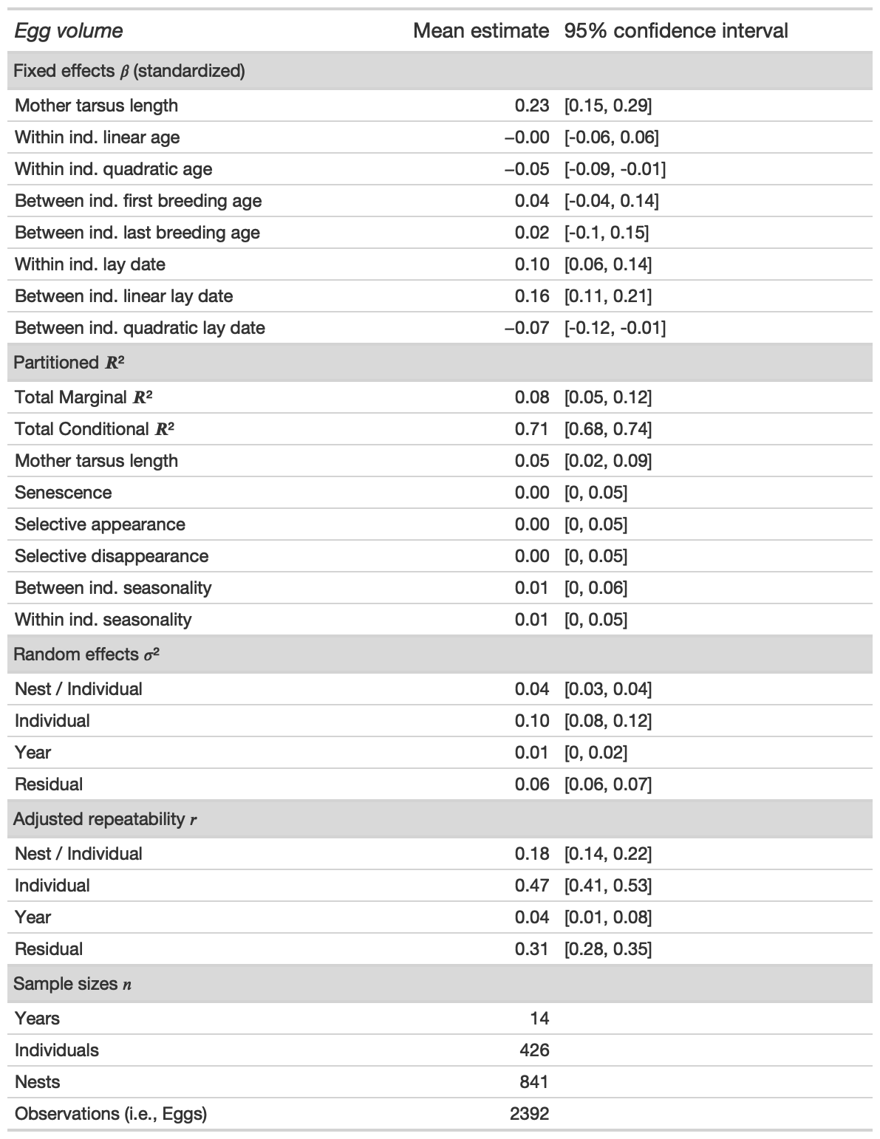**Table S3.** Sources of egg size variation.

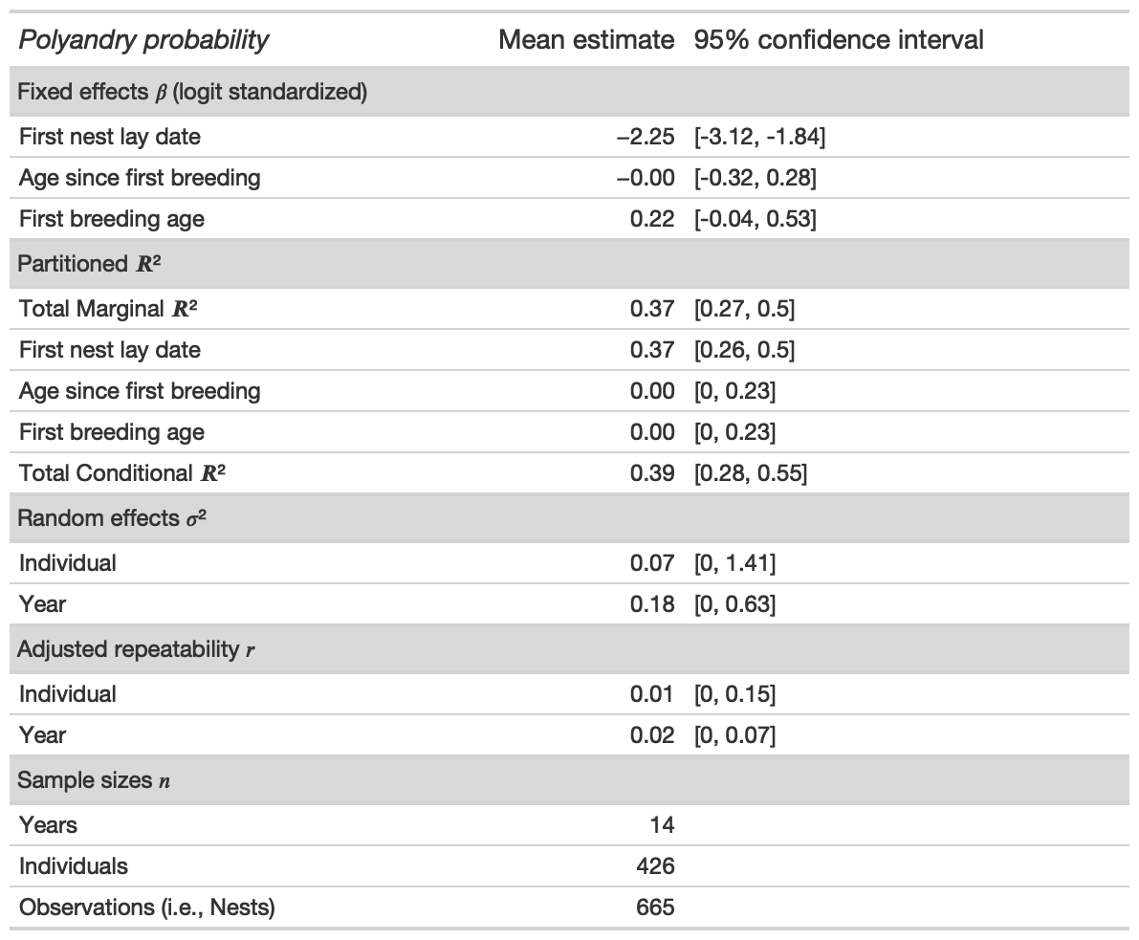**Table S4.** Relationship between the lay date of an individual’s first nest and their likelihood of polyandry each year. Fixed effect size of ‘first nest lay date’ is the standardized estimate on the logit scale.

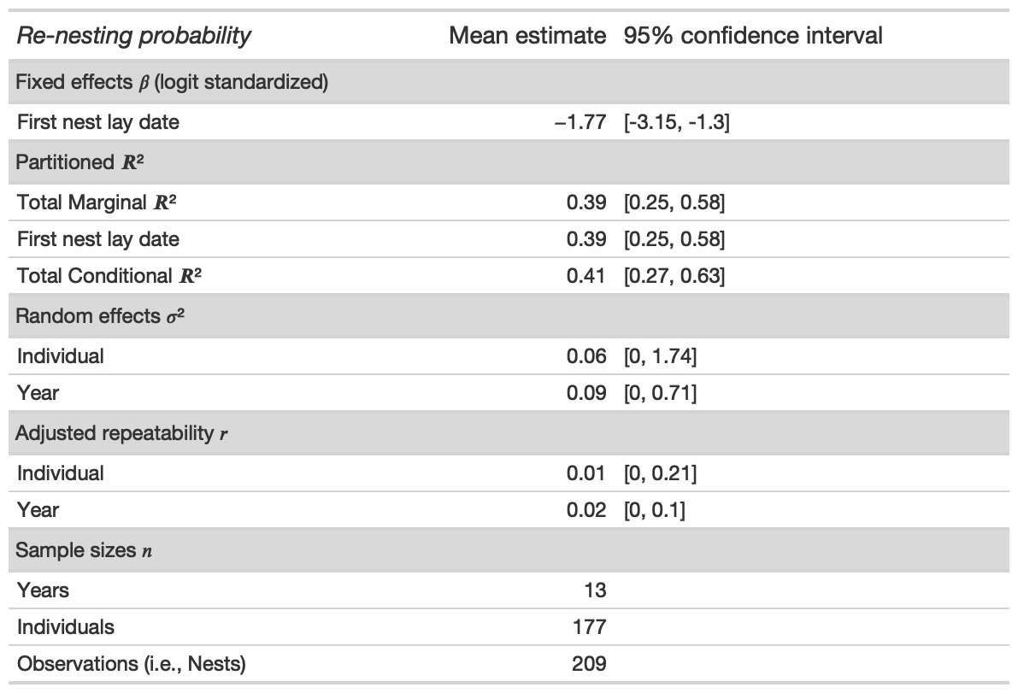**Table S5.** Relationship between the lay date of an individual’s first nest and their likelihood of re-nesting following breeding failure in a given year. Fixed effect size of ‘first nest lay date’ is the standardized estimate on the logit scale.

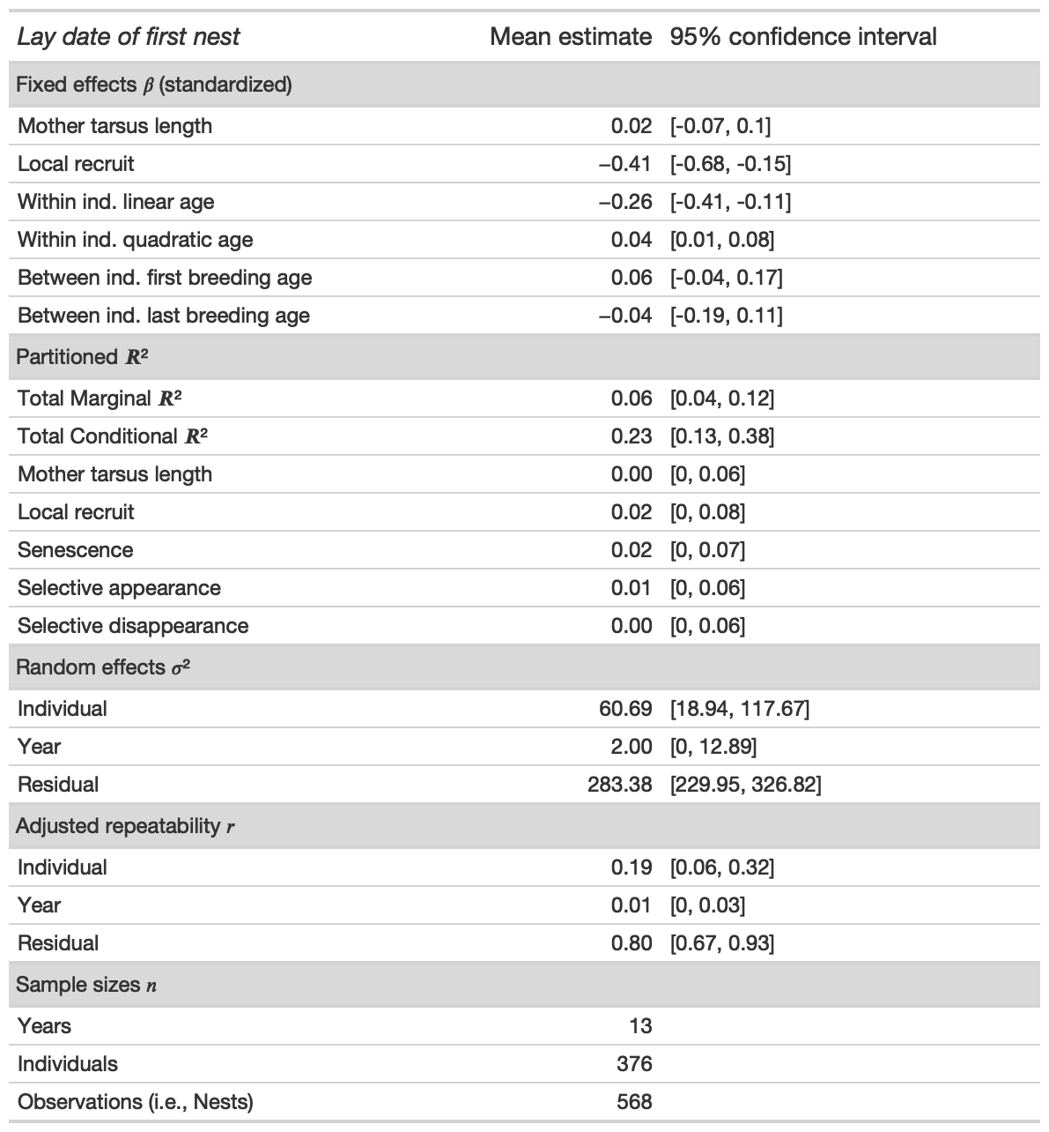**Table S6.** Sources of lay date variation.

**Figure S1.** Egg size variation for snowy plovers breeding in Bahía de Ceuta, Mexico between 2006 and 2020. Egg volume was estimated using an allometric equation combining length (A) and width (B) measurements collected in the field (see *Methods*). C) Average egg volume of a clutch was highly correlated with the clutch’s average chick weight at hatch (*β* [95% CIs]: 0.628 [0.552–0.704]; R2*marginal* = 0.370 [0.310–0.436]). Ribbon shows the 95% CI of the model prediction, vertical and horizontal error bars visualize within clutch variation in egg volume and chick hatch weight (1 SD); see Appendix S2 for modelling methods.

**Figure S2.** Bayesian model diagnostics of the Logistic bathtub shaped survival model. a) Serial autocorrelation of iterations within chains, b) chain convergence (*R-hat*) of model, and c) trace plots of chain dynamics.

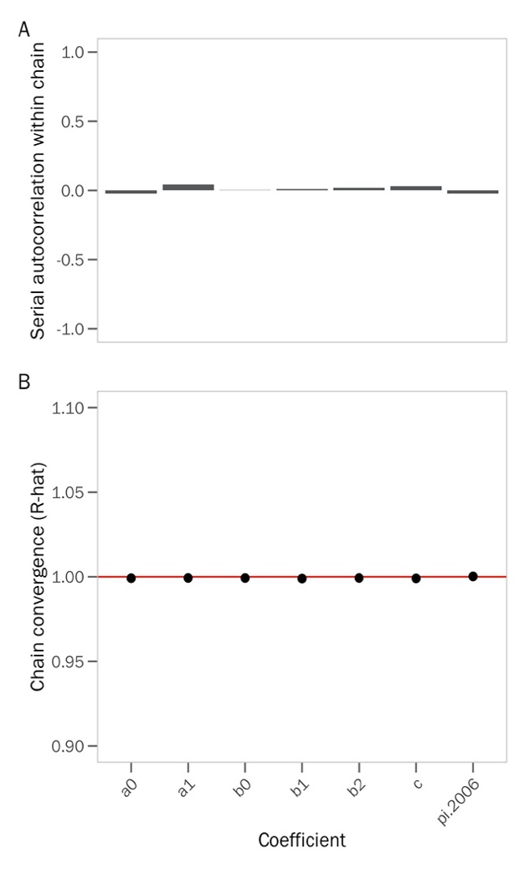

**Figure S3.** Sources of variation in the average hatch weight of chicks.

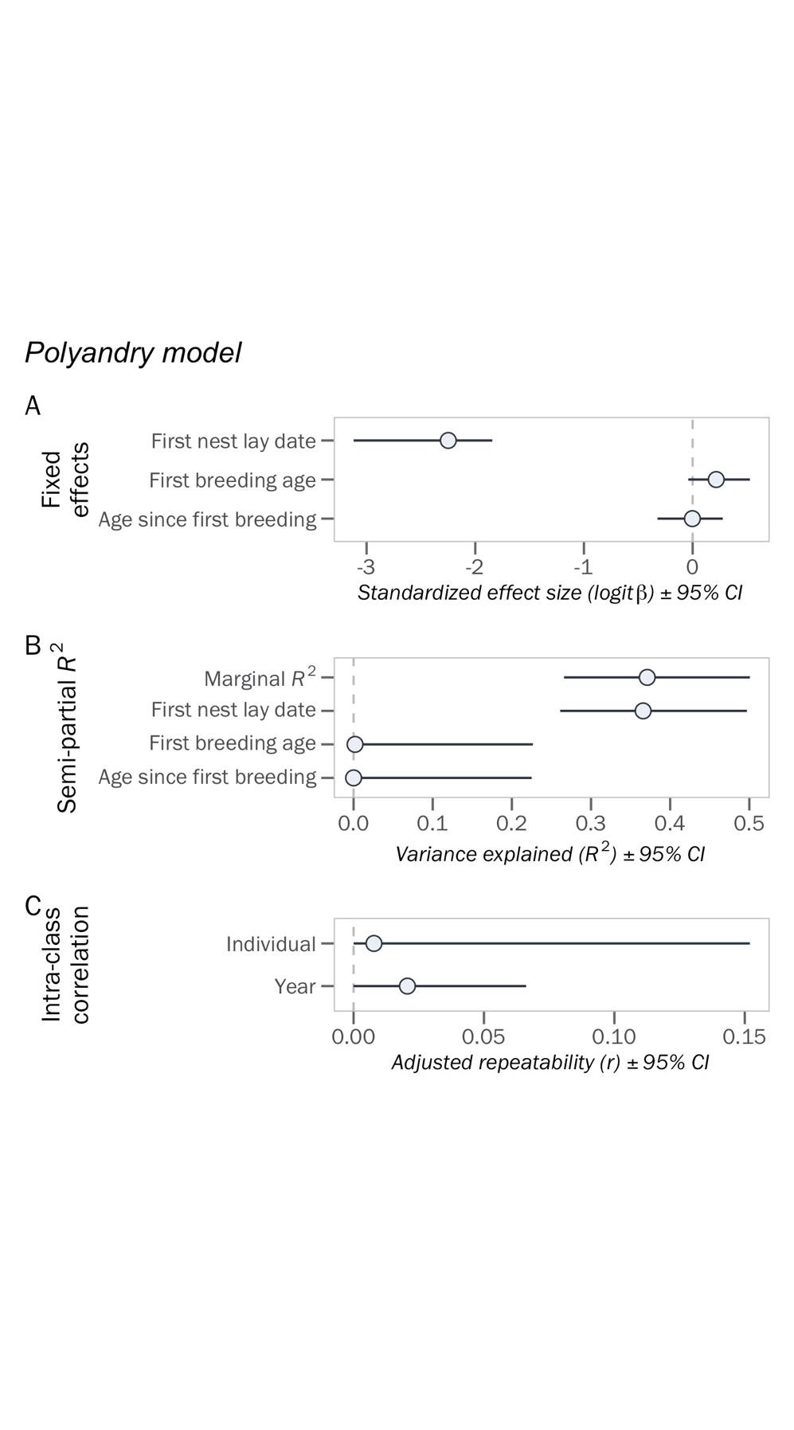**Figure S4.** Sources of variation in a female’s probability of being polyandrous each year.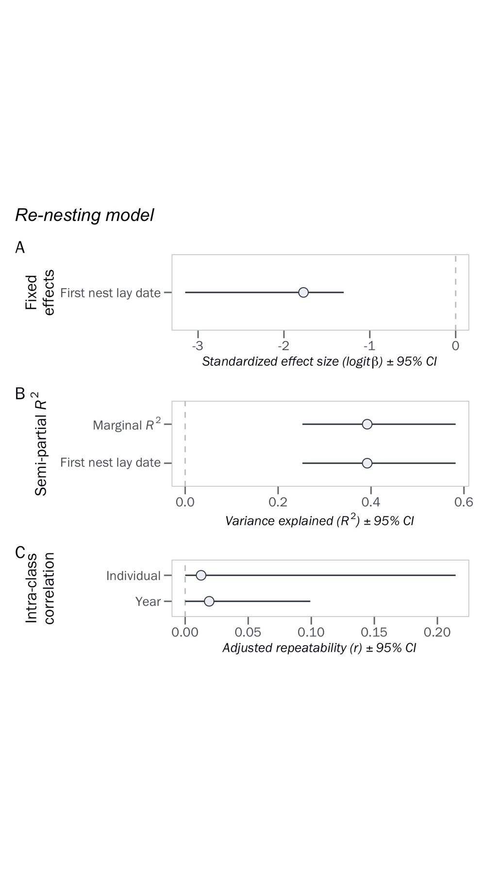**Figure S5.** Sources of variation in a female’s probability of re-nesting after a failed attempt each year.

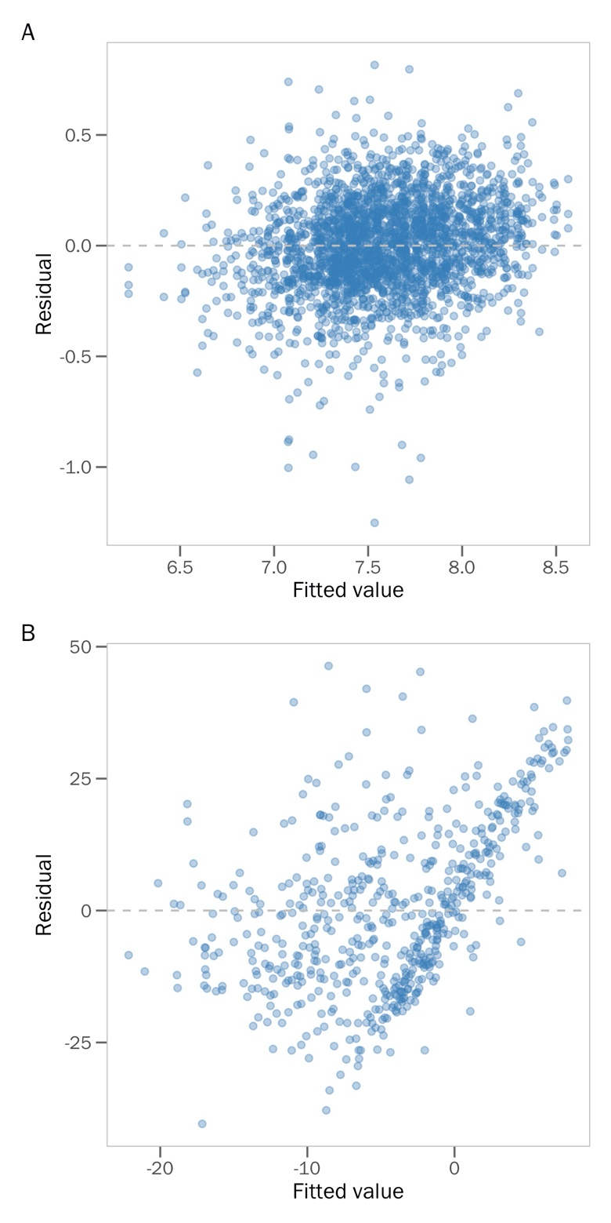**Figure S6.** Homoscedastic spread of residuals from the A) ‘egg volume’ and B) ‘lay date’ models.

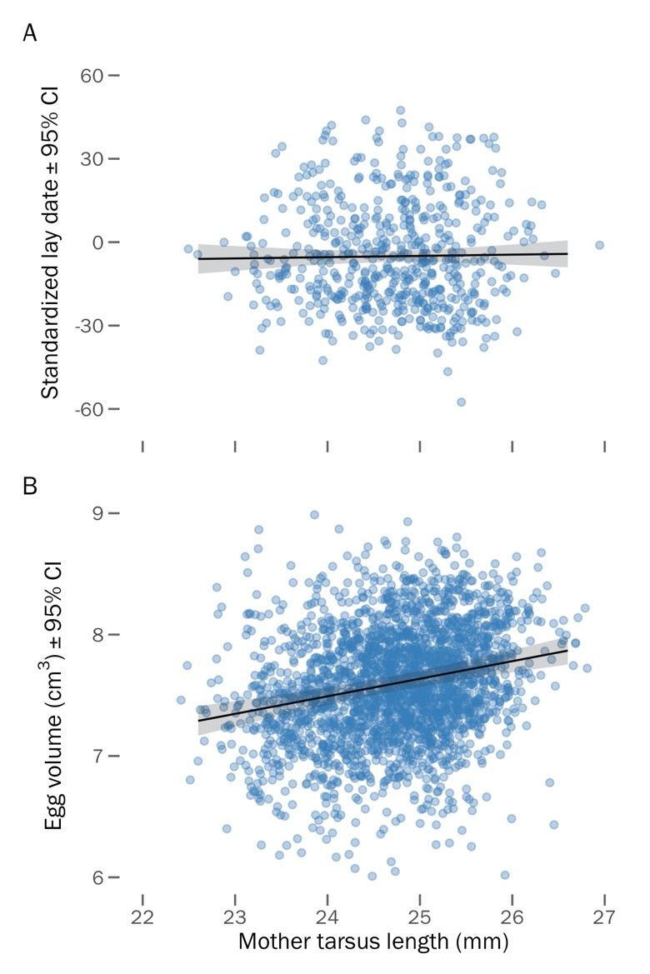**Figure S7.** Relationship between a female’s structural size (i.e., her tarsus length) and A) the lay date of her first nest of the season, and B) the volume of her eggs.

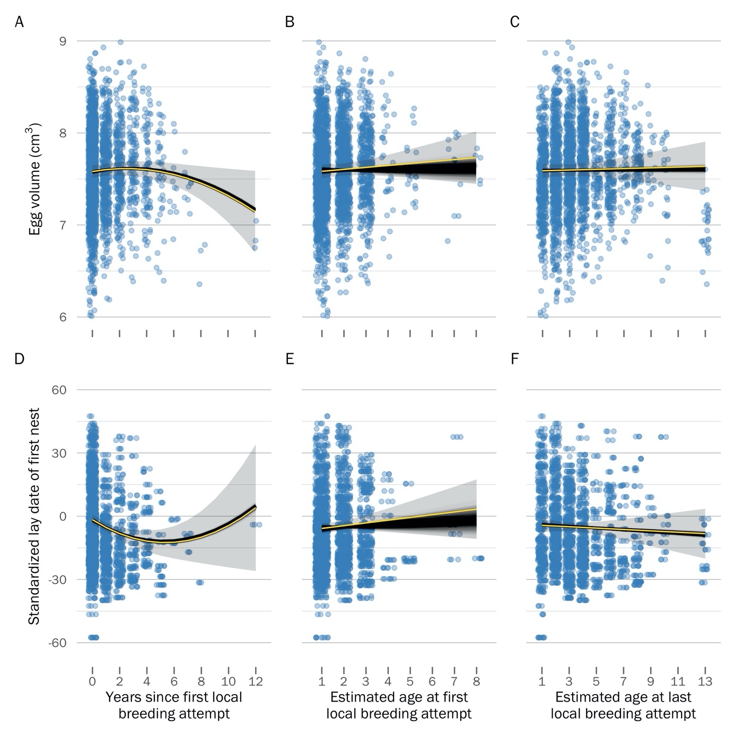**Figure S8.** Visualization of the effect of uncertainty in the age estimate provided by BaSTA on age-dependent trends in egg volume (top row) and lay date (bottom row) dynamics. Black trends show the model predictions for the 1000 bootstraps of the BaSTA age estimate posteriors (see *Methods*).Panels A and D show the within-individual trends of the ‘age-deviation’ score – as expected, these measures are not impacted by uncertainty in the BaSTA age estimate because they are centered for each individual (i.e., the absolute age is irrelevant). Panels B and E show the between-individual trend of the ‘age at first breeding’ (i.e., selective appearance), and panels C and F show the between-individual trend of the ‘age at last breeding’ (i.e., selective disappearance). Yellow trends and grey ribbons visualize the 95% CI of the model predictions when using the mean age estimate provided by BaSTA (i.e., the effect sizes of the ‘egg volume’ and ‘lay date’ models shown in Fig. 3).

**File S1.** Commented RMarkdown vignette detailing the analytical steps needed to reproduce all our models and results. Click here to view on your internet browser:

<https://raw.githack.com/leberhartphillips/snowy_plover_eggs/main/Seasonal--and-age-related-egg-size-variation-in-a-long-lived-polyandrous-shorebird.html#data-import-and-wrangle>

**Appendix S1.**

To explain how mortality risk is associated with age, we compared four commonly used survival functions: exponential, Gompertz, logistic, and Weibull models. The exponential function keeps survival constant across age

(Cox & Oakes, 1984), whereas the other functions allow for age-dependent variation in survival: the Gompertz model is an exponential function in which age-specific mortality is scaled by baseline mortality (Gompertz, 1812; Pletcher, 1999) and the Weibull model is a power function which assumes that baseline and age-specific mortality rates are independent (Pinder *et al.*, 1978). In addition to the stand-alone versions of these functions, we considered two alternative forms of the Gompertz, logistic, and Weibull functions – “Makeham” and “bathtub” shapes. The Makeham shape constrains the survival function to converge to a constant, rather than zero, as age increases(Pletcher, 1999), whereas the bathtub shape enables concavity in the function, such that mortality could decrease at early ages, but increase later in life (Siler, 1979).

We used four parallel simulations to run the Markov chain Monte Carlo (MCMC) optimization procedure in BaSTA with 800,000 iterations, a 100,000 burn-in period, and a thinning interval of 2000 to minimize serial autocorrelation in the chain (see Fig. S1 for simulation diagnostics). We ranked the survival models according to their deviance information criterion (*DIC*) and determined that the logistic model with a bathtub shape fitted our data best (i.e., lowest *DIC*, (Spiegelhalter *et al.*, 2002); Table S1). This logistic model revealed that female mortality rate increased until age 5 years, after which it became constant (Fig. 1b). Using the top model, we extracted the point estimate and 95% credible interval birth year for each individual in the capture-mark-recapture sample.

**Appendix S2.**

In theory, the selective benefits of larger eggs is that the subsequent hatchlings will be larger and have higher survival owing to more intrinsic reserves provided by the mother (Blomqvist *et al.*, 1997). To link egg size variation to potential fitness consequences of subsequent offspring we evaluated the predicted positive relationship between egg volume and chick weight using the egg dataset described above but reduced observations to the nest level and filtered to only include nests that had chicks measured within one day of hatching, resulting in 456 nests from 276 females. As it was unclear which chick came from which egg, each datum represented the nest-level average of chick weights and egg volumes. We included random intercepts for mother identity and year, and assumed a Gaussian error distribution of egg volume.